STRATHAVEN MODEL SOCIETY Ltd

Registered Office and Clubrooms Company Secretary
2 Dunlop Street
Strathaven 2 Dunlop Street
South Lanarkshire Strathaven
ML10 6LA South Lanarkshire
ML10 6LA

Web address: - www.strathavenminiaturerailway.org
- Facebook.com/strathavenminiaturerailway

News Letter February 2018
Dear Member,

Members Information
To allow for work to be completed on the carriages and driver training on Strathaven Castle our season will commence on Saturday the 24th of March this year. See Strathaven Castle note below.
Both Ian K. and Ian MacD, continue to recover from there surgery last month with visits to hospitals now for check-ups on their progress. Other members have been ill during the last month or so and are also making headway and expect to back with us in the near future.
Thank you to the 19 members who have already paid their membership in January that is almost 50% of the current membership. Those still to pay please do so by the end of March 2018.
.
Winter work Schedule
Work continues in the workshop with several of the smaller to do items completed. Hand pump for EVA stripped and refurbished. From EVA’S back head we have removed the gauge glasses and gauge glasses blow downs to be cleaned and new glass ware to be fitted. Point’s quadrant for the station similarly stripped and upgraded with grease points similar to the other quadrant, now painted and installed back in the park thanks Allan and Jay. Two of the carriages in the workshop near completion with a new airline systems installed and upgrades made (All new components fitted) hopefully this will reduce or cure our issues with airline bleed off. Eight new Wheels and four axles have been made for carriage No. 3 bogies. Wheels now fitted to axles and will be installed into carriage shortly, once new ‘O’ rings are fitted to brake pistons. We would expect to have the other carriages in the workshop over the next few weeks to have all new fittings installed ready for Easter weekend. See updated to do list attached. Please assist with this ongoing work.

Kiosk & Containers
In the kiosk we had a few squatters taking up home (A mouse or two) they had managed to get into one of the cupboards and had eaten their way into a bag of sugar. The area has now been cleaned out and any food stuff that was available for them removed. All surfaces cleaned and disinfected. All the cups and other dishes have been through the dishwasher. All towels (dish and hand) again washed and put back in the drawer ready for the new season.
Container two continues to be cleaned out with several items ready to go to the recycle centre or find new homes where applicable.

WORKSHOP
While all this work is being done on the society’s rolling stock in prepeartion for the new season, work has had to be suspended on our Black 5 (Highlander)..
Gordon had been working his way around the workshop benches etc and has been able to tidy these areas creating space. The metal store will be tackled later in the year. I have started in the office and hope to create a library space for books ,dvd’s for members use .

STRATHAVEN CASTLE

Update from the builder locomotive will be finished hopefully today with airbrakes system tender tank being fitted. Once tested the loco will be stripped down and painted as per our request. See attached pictures of the driver’s board and braking system for the tender with brakes operating on all four wheels. All going well delivery of locomotive will be first week of March.
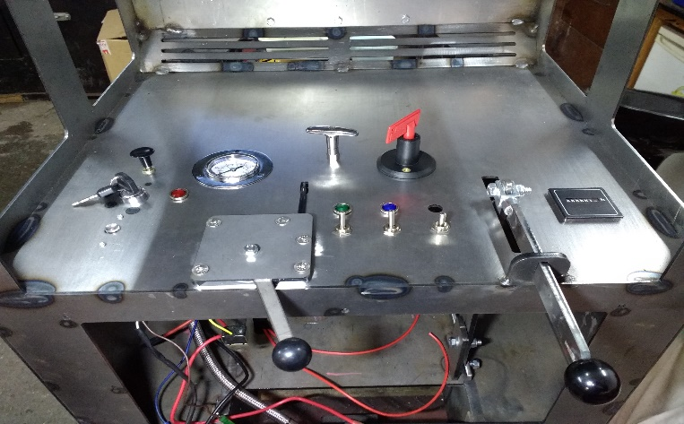
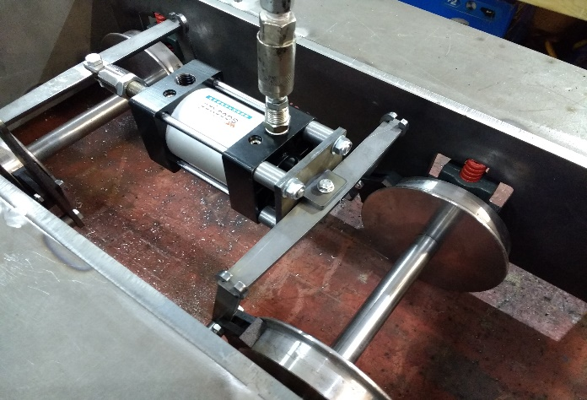

Dates for your DIARY 2018
Saturday the 24th of March first running day of new season.
Saturday the 31st of March Easter Saturday
Sunday the 1st of April Easter Sunday
Monday the 2nd of April Easter Monday
Monday the 7th of May Bank holiday
Monday the 28th of May Bank Holiday
Saturday the 9th of June GALA DAY
Sunday the 17th of June Father’s Day
Saturday the 30th of June (first weekend after schools break for summer holidays)
Saturday the 7st of July Pipe Band Festival CANCELLED LACK OF SUPPORT
Monday the 16th of July Glasgow Fair holiday
Saturday the 28th of July Folk Festival
Saturday the 11th and Sunday the 12th of August last weekend before Schools go back S.L.C.
Saturday the 25th of August Balloon Festival
Sunday the 26th of August Balloon Festival
Saturday the 22rd of September (September weekend holiday)
Sunday the 23rd of September (September weekend holiday)
Monday the 24th of September (September weekend holiday)
Sunday the 30th of September last running day (Any running after this date in the Park would be donations only)

Saturday the 13th of October (Club Open Weekend) No public running
Sunday the 14th of October (Club Open Weekend) No public running
Schools on Holiday the 13th to 21st 0f October optional running weather dependent. Voluntary and donations only

Saturday the 3rd of November GUY FAWKES LATE AFTERNOON/EVENING RUNNING.

Help with all the work mentioned would be appreciated either in the workshop or around at the park weather permitting. Hopefully see you in Dunlop Street soon.

Kind regards

Ian

