STRATHAVEN MODEL SOCIETY Ltd

Registered Office and Clubrooms Company Secretary
2 Dunlop Street
Strathaven 2 Dunlop Street
South Lanarkshire Strathaven
ML10 6LA South Lanarkshire
ML10 6LA

Web address: - www.strathavenminiaturerailway.org
- Facebook.com/strathavenminiaturerailway

News Letter March 2018
Dear Member,

Members Information
To allow for work to be completed on the carriages and driver training on Strathaven Castle our season will commence on Saturday the 24th of March this year. See Strathaven Castle note over page.
As of today 30 of our 40 members have renewed their membership and I know of several cheques in the post but have been held up by the weather recently. In Strathaven no post delivered at the end of last week. If you have still to renew your membership please do so before month end. A.G. M will be held on the 17th of April at 19.00 hrs in the Barrie shelter as usual. We appear in two annual publications (Tiny Trains) Guide to Britain’s Miniature Railways. This publication is normally £9.99 per copy, we have been offered a special price of £4.99 if you wish a copy please let me know (May publishing date) order to be placed in March. The other publication is (ON THE RAILS 2018) published by Peco and is given free with Railway Modeller, April/ May issue again I have updated our profile.
.
Winter work Schedule
Work progresses with 5 carriages now complete with a new working airbrake system using compression joints rather than push fit. All cylinders and valves have been replaced along with the airline piping. Three of the carriages tested on track last week with excellent results. One final carriage to go through the workshop and then the other three carriages will be returned to the park for testing in the next week. Eva has had all fittings on the back head removed and cleaned or modified as required with new gauge glasses fitted today. Just blow down piping to be finished. Thereafter cylinder gasket and packing of glands to be checked. As EVA has a steel boiler she requires a hydraulic and steam test before returning to the park.
See updated to do list attached. Please assist with this ongoing work.

Kiosk & Containers
Kiosk was checked for burst pipes today, happy to report all seemed to be ok. Container two continues to be cleaned out with several large items removed last week. Would hope that the last of the large items will be removed next week. We then need to consider what will be the configuration of the container for future use and when will we replace with a new insulated container.

WORKSHOP
Gordon had been working on the metal store and already a difference can be seen with old pieces of machinery and nuts and bolts that would grace a full size locomotive being removed . It is plannned that we reduce our holding of metal, some of which has been there for years and only hold what is needed and buy in as and when required for the future.

STRATHAVEN CASTLE
New photograph of Strathaven Castle received today. Side louvers to be fitted and coach lining to be completed this week. Final check over of locomotive and then she is ready for delivery. Spoke with Chris today and will hopefully have a fixed date for Locomotive to arrive in Strathaven before the 16th of March.

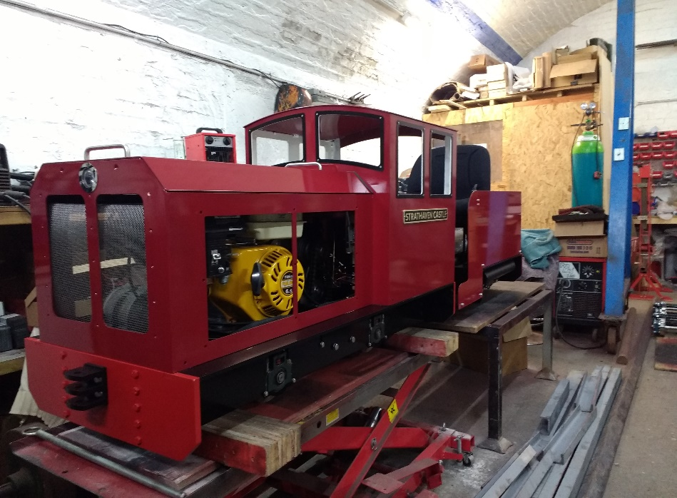

Dates for your DIARY 2018
Saturday the 24th of March first running day of new season.
Saturday the 31st of March Easter Saturday
Sunday the 1st of April Easter Sunday
Monday the 2nd of April Easter Monday
Tuesday the 17th of April A.G.M.
Monday the 7th of May Bank holiday
Monday the 28th of May Bank Holiday
Saturday the 9th of June GALA DAY
Sunday the 17th of June Father’s Day
Saturday the 30th of June (first weekend after schools break for summer holidays)
Saturday the 7st of July Pipe Band Festival CANCELLED LACK OF SUPPORT
Monday the 16th of July Glasgow Fair holiday
Saturday the 28th of July Folk Festival
Saturday the 11th and Sunday the 12th of August last weekend before Schools go back S.L.C.
Saturday the 25th of August Balloon Festival
Sunday the 26th of August Balloon Festival
Saturday the 22rd of September (September weekend holiday)
Sunday the 23rd of September (September weekend holiday)
Monday the 24th of September (September weekend holiday)
Sunday the 30th of September last running day (Any running after this date in the Park would be donations only)

Saturday the 13th of October (Club Open Weekend) No public running
Sunday the 14th of October (Club Open Weekend) No public running
Schools on Holiday the 13th to 21st 0f October optional running weather dependent. Voluntary and donations only

Saturday the 3rd of November GUY FAWKES LATE AFTERNOON/EVENING RUNNING.

Kind regards

Ian

