STRATHAVEN MODEL SOCIETY Ltd

Registered Office and Clubrooms Company Secretary
2 Dunlop Street
Strathaven 2 Dunlop Street
South Lanarkshire Strathaven
ML10 6LA South Lanarkshire
ML10 6LA

Web address: - www.strathavenminiaturerailway.org
- Facebook.com/strathavenminiaturerailway

News Letter April 2018
Dear Member,

Members Information
At the end of March 38 members have renewed their membership with two pending thank you to those who renewed to date. At a meeting of directors earlier this month it was deemed appropriate to make Robert (Bobby) Watt our first honorary member after 30 thirty years plus of service to the society. As most of you know Bobby can no longer take part in active work within the society due to failing eye sight but is still very interested in our day to day running. We wanted him to still feel part of our organisation after all that he has done for both the club and other members.
Attached you will find an updated contact list, competent drivers list along with an updated track safety guidelines booklet. Under the data protection act please destroy any existing listed by shredding, burning or cutting into small pieces. You are responsible for destroying yours and colleagues data responsibly please.
.
Winter work Schedule
All carriages returned to the track in the park before our first running day on the 24th of March. All carriages tested singly and in train formation with excellent results throughout regarding braking and function of the system. Well done to all who saw this task through to the end. EVA had her hydraulic and steam tests carried out, passing both with minor tweaks on gauge glass fittings. You will see on the attached sheet all other work has now been completed at the end of March. As for the containers we will consider replacing them during the season now that they have been cleaned out and made ready for removal and replacement at the appropriate time.
See updated to do list attached.

Kiosk & Containers
Kiosk still being heated due to the adverse weather we have had over March and the Easter weekend. We are now considering what layout will be required for container two. This will store club 5”ground and the raised track carriages plus items for Guy Fawkes Night etc. Society member’s locomotives will also have storage space within this unit.

WORKSHOP
Walked into the workshop on Monday morning and had to look twice at the transformation that has taken place over the last week now that all the carriages and EVA have been returned to the park. Thank you to all who took part in the big clean up, tools , equipiment, benches all cleaned and or returned to there correct storage space. All the drills and airline equipment evaluated and now stored in appropriate containers. Please can all members try to keep it like this here in the workshop and at the kiosk in the park.

STRATHAVEN CASTLE
Picture below of Strathaven Castle on her first day on duty 24th of March in the park the calm before the work started. Locomotive had arrived from London late afternoon of the 19th of March and was commissioned on the Tuesday going through the operation and servicing of the engine. On the 24th we had over 200 paying passengers mainly hauled by Strathaven Castle with a little help from her stable mate Abberton. On the three days that we have managed to run, Strathaven Castle has been the locomotive of choice pulling just under six hundred paying passengers.

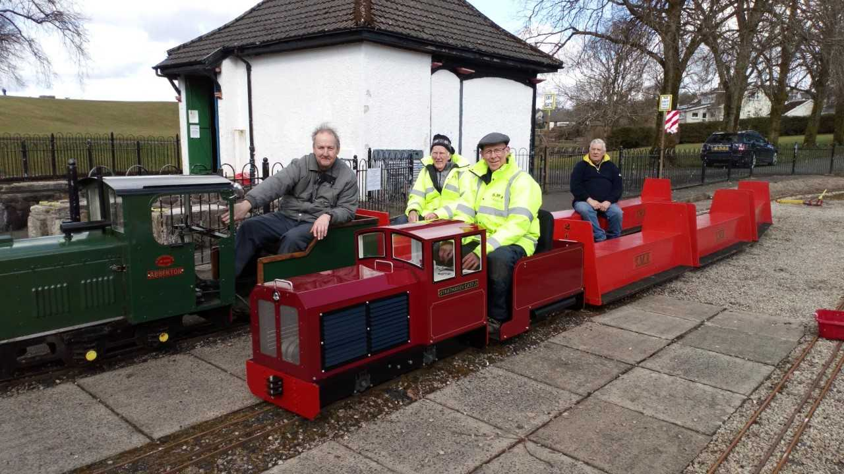

If weather permits we are looking to finish the track work on the back straight on Monday the 9th of April. Please if you can manage to assist in this task, your help would be appreciated.

Dates for your DIARY 2018
Tuesday the 17th of April A.G.M. 7.00pm in the Pavilion within Strathaven park.
Monday the 7th of May Bank holiday
Monday the 28th of May Bank Holiday
Saturday the 9th of June GALA DAY
Sunday the 17th of June Father’s Day
Saturday the 30th of June (first weekend after schools break for summer holidays)
Saturday the 7st of July Pipe Band Festival CANCELLED LACK OF SUPPORT
Monday the 16th of July Glasgow Fair holiday
Saturday the 28th of July Folk Festival
Saturday the 11th and Sunday the 12th of August last weekend before Schools go back S.L.C.
Saturday the 25th of August Balloon Festival
Sunday the 26th of August Balloon Festival
Saturday the 22rd of September (September weekend holiday)
Sunday the 23rd of September (September weekend holiday)
Monday the 24th of September (September weekend holiday)
Sunday the 30th of September last running day (Any running after this date in the Park would be donations only)

Saturday the 13th of October (Club Open Weekend) No public running
Sunday the 14th of October (Club Open Weekend) No public running
Schools on Holiday the 13th to 21st 0f October optional running weather dependent. Voluntary and donations only

Saturday the 3rd of November GUY FAWKES LATE AFTERNOON/EVENING RUNNING.

Kind regards

Ian

