STRATHAVEN MODEL SOCIETY Ltd

Registered Office and Clubrooms Company Secretary
2 Dunlop Street
Strathaven 2 Dunlop Street
South Lanarkshire Strathaven
ML10 6LA South Lanarkshire
ML10 6LA

Web address: - www.strathavenminiaturerailway.org
- Facebook.com/strathavenminiaturerailway

News Letter September 2018
Dear Member,

Members Information

Last Friday early evening our friend and colleague Brian Sullivan passed away with his family around him. As you know Brian had surgery earlier this year to remove a brain tumour which appeared to be successful at the time. Unfortunately there was a secondary tumour which was deemed inoperable and other treatment would be considered but to no avail. At the time of writing I have no other information about arrangements for Brian’s funeral. As a Society we arranged for flowers to be sent to Margaret, Sharon and Colin and their respective families.

Two new members joined our Society in the first weeks of August Alan from Blackwood and Angus from Strathaven please welcome on board our new members and assist them as and when they are on duty at the park or in the workshop. Both Alan and Angus have had their first drive of Strathaven Castle and can drive under supervision petrol only locomotives at present. Angus has also been active in the workshop on Tuesday evening assisting with preparation work for the track extension.

Ian Kerr visited the workshop and the park on Monday and is looking well after recovering from the heart surgery earlier this year. He is in the process of moving house at present and is waiting for his new land line (new number) to be installed so if you have tried to make contact recently this is the reason you did not reach him. I know that several members have been in contact with Campbell and I am pleased to say he is continuing to make a steady recovery and is keeping active at home.

Running Days 2018
August turned out to be a bad and a good month! Our passenger numbers for August were 2420 down on last year by 719, this was mainly due to several days being rained off during the month. This now gives us a running total year to date of 13,517 which keeps us ahead of last year by 1102 passengers.
The Balloon festival this year was one of two halves, the Saturday was one of the highlights of the summer with massive crowds in the park estimated at 15,000 attendees to the Balloon Festival. This in turn gave us our most successful day ever on our existing track with 1432 passengers hauled between 09.30 and 19.30. The only day that has been recorded with a higher running total was in 1949 with 1548 tickets sold. The track at that time was only 100 metres compared with now, nearly 700 metres today. On the Sunday we hauled 26 passengers, the Balloon Festival was cancelled by the organisers early afternoon as the weather was so poor. A BIG THANK YOU to all who assisted over the festival weekend.
Our first weekend of September was also a poor one with the weather curtailing visitors to the park 55 on Saturday and 135 for the Sunday. We just have to wait and see how the rest of the month will go and hope that the weather will be kinder to us.

Track Work
Grass edges were trimmed around the ground track where the grass had started to ingress on the track. Allan and David worked on cleaning up the turntable sidings and replacing the edging slabs around the area after the new raised track cutting was finished. We are looking to move and relay several two by two slabs in the park this Monday coming. September 10th in the park volunteers required to help with this task weather permitting.
New raised track several discussion points have been raised about the track and its construction and meetings have been convened to discuss these issues, next meeting will be Monday the 10^{th of} September. We have had information back from the local steel bending company which has not been helpful and could possibly make us have to change our plans or think of another way to accomplish this part of the work to be done.

WORKSHOP
Work continues in the workshop cutting steel plate and making spacers and cutting screwed rod to size. This when all put together will assist with assembly of the track. At the same time Mike and Allan have re-commenced work on the society’s Black 5 locomotive. If you have not been in the workshop for some time the wheels are now on the loco with most of the motion also in place. Both are hopeful of having the motion work tested on air later this year.

STRATHAVEN CASTLE
The art work for the two brass plaques were given to a foundry in Glasgow to make the plaques. We have one now but the other was rejected as it was deemed to be poorly finished. The replacement unit is due this week. Please see attached picture of what the plaques will look like, these will then be fitted to S.C tender.

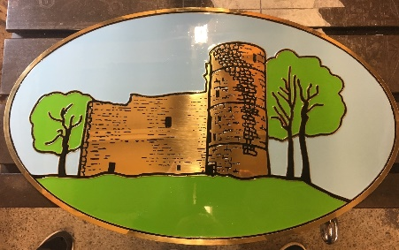

70th Anniversary in 2019
Our pin badges for next year have arrived early and will be available for sale at the Open weekend in October. Price for these collector’s items will be £1.00 per badge. They will then go on sale throughout 2019 at the park sold separately from the tickets sales by another member of the crew on duty on running days.
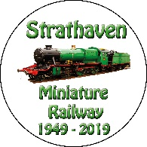

Dates for your DIARY 2018

Saturday the 22rd of September (September weekend holiday)
Sunday the 23rd of September (September weekend holiday)
Monday the 24th of September (September weekend holiday)
Sunday the 30th of September last running day (Any running after this date in the Park would be donations only)
Saturday the 13th of October (Club Open Weekend) No public running
Sunday the 14th of October (Club Open Weekend) No public running
Schools on Holiday the 13th to 21st 0f October optional running weather dependent. Voluntary and donations only.
Saturday the 3rd of November GUY FAWKES LATE AFTERNOON/EVENING RUNNING.

Kind regards

Ian

