STRATHAVEN MODEL SOCIETY Ltd

Registered Office and Clubrooms Company Secretary
2 Dunlop Street
Strathaven 2 Dunlop Street
South Lanarkshire Strathaven
ML10 6LA South Lanarkshire
ML10 6LA

Email: -strathavenminiaturerailway@gmail.com
Web address: - www.strathavenminiaturerailway.org
- Facebook.com/strathavenminiaturerailway

News Letter March 2020
Dear Member
Members Information

Thank you to the 30 out of our 43 members who have already returned their renewal forms and their membership fee for 2020. Those who have still to renew membership please do so before the end of this month.
For those who know Michael C, he has had his second round of surgery and is making a good recovery. We hope to see him up at the park in the near future. Both our new honorary members Kenny J. and Campbell R. have contacted me to thank the society for this recognition for their service over the past years. We wish them both well and hope to see them visit us over the running season. We received in the last few days of February our money from the S.L.C. grant committee, this was to assist the purchase of the containers, which we had bought in December.

WORKSHOP & Raised Track
In the workshop the last section was made or so we thought! After studying the drawings we had a small section missing from the displayed drawing and we now need to make one more full length of straight. Thereafter we will have three or four short straight sections to complete all the requirements for the park , these last ones will be made after all the track is in the place and we can see what is required to be made. Fish plates and final end pieces will be fitted shortly and then sections can be moved to the park.
With ONLY 3 MONDAYS AND TUESDAY left till we start operating for 2020 the main focus now will be on getting all the checks and maintance completed on the rolling stock at the park.Eva and Margaret have been returned to the park after all maintenance completed. Eva has had her steam test today and is now ready for the new season. Margaret will have her annual steam test next week weather permitting. Carriage bogies were allgreased up and airlines checked . Only one carriage will need further investigation regarding air brakes (sticky valve).
Raised track steel pillars were sent to Scottish Galvanisers in Glasgow mid February and have now been returned to us after the work was completed. Scottish Galvanisers completed the work and dispensed with charging for the work. We have thanked them on our website and facebook pages for this generous gift.
Before and After pictures below.

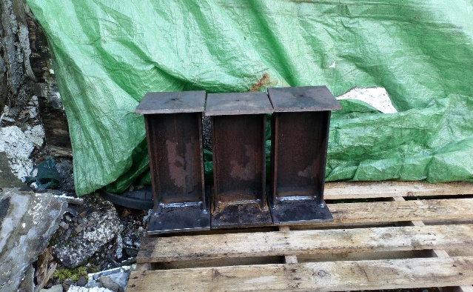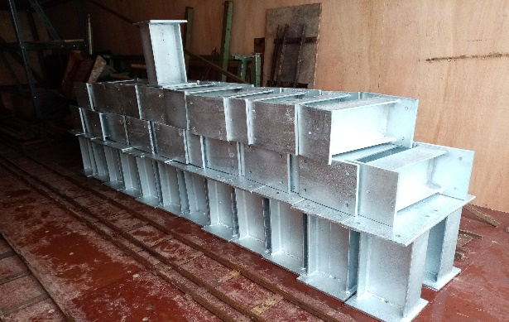

Park & Kiosk

The weather over the last few weeks have held us back in the park and several pieces of work will need to be completed before running season starts. Kiosk requires to be cleared of Guy Fawkes items lights etc which need to go back to the appropriate container. The kitchen and sink area along with the locomotive store all require cleaning ready for the new season. We had water ingress at the kiosk and this was reported to S.L.C. who have promised that they will send a roofer to check and repair where required. All raised track and ground level 5̎ carriages will also be checked over especially the ground carriages we take to the Hamilton museum in April.

Proposed New Locomotive (Keep this information confidential please) We want to surprise the company

We are proposing to buy a battery locomotive 5̎ scale (Deltic) and we will name this locomotive CAIRNHILL after the company who supplied all the steel for the raised track and has supported us in other ways throughout the project and they are still offering assisstance if and when required. This loco would be for the use of all members on the raised track at all times and when no passenger hauling on the ground track. We can expect delivery of this locomotive in early June 2020 as it will be built to order. We would then hope to have our benefactor come to the park and name the locomotive sometime in the summer.

Dates for your DIARY 2020
A.G.M. will be held in the Bowling Pavilion of the Barrie Shelter on the 21st of April 2020 at 19.00 hrs

Saturday the 28th of March 2020 first running day of the new season.
Saturday 4th & Sunday 5th of April Hamilton Museum exhibiting and running locomotives as part of the Museums South Lanarkshire (Coal, Steam and local industry exhibition)
Start of school Easter holidays Saturday the 4th of April.
Saturday the 11th of April Easter Holiday
Sunday the 12st of April Easter Holiday
Monday the 13th of April Easter Holiday
Sunday the 19th of April Finish of schools Easter holidays (South Lanarkshire)
Tuesday the 21st of April A.G.M. bowling pavilion 19.00hrs.
Friday the 8th of May Bank holiday (VE Day 75th Anniversary)
Monday the 25th of May Bank holiday
Saturday the 13th of June GALA DAY
Sunday the 21th of June Father’s Day
Saturday the 27th of June (first weekend after schools break for summer holidays)
Monday the 13th of July Glasgow Fair holiday
Saturday the 8th and Sunday the 9th of August (last weekend before Schools go back S.L.C.)
Friday the 28th of August Balloon Festival Evening (16.00 – 21.00)
Saturday the 29th of August Balloon Festival All Day Running
Sunday the 25th of August Balloon Festival All Day Running
Saturday the 26th of September (September weekend holiday)
Sunday the 27th of September (September weekend holiday)
Monday the 28th of September (September weekend holiday) (Any running after this date in the Park would be donations only)
Saturday the 10th of October (Club Open Weekend) No public running
Sunday the 11th of October (Club Open Weekend) No public running
Schools on Holiday the 9th to 19th of October optional running weather dependent. Donation only.
Saturday the 7th of November GUY FAWKES LATE AFTERNOON/EVENING RUNNING. Approx 5.00pm to 9.00 pm weather permitting.

For 2020 we will have 60 running days if the weather is kind to us, similar to 2019, this includes the extra evening running on the Friday of the Balloon festival which was a very successful night last year.

Kind Regards
Ian

