STRATHAVEN MODEL SOCIETY Ltd

Registered Office and Clubrooms Company Secretary
2 Dunlop Street
Strathaven 2 Dunlop Street
South Lanarkshire Strathaven
ML10 6LA South Lanarkshire
ML10 6LA

Email:strathavenminiaturerailway@gmail.com
Web address: - www.strathavenminiaturerailway.org
- Facebook.com/strathavenminiaturerailway

News Letter November 2020

Keep Safe and Well during these exceptional times

Dear Member
Members Information
With the running season now finished, we turn our attention to the winter work and availability of members to do this work. We have several issues for the next few months, with South Lanarkshire now being in Tier 3 and some of our members living out with the area in lower tiers. To comply with guidelines this makes it impossible for them to travel to Strathaven and comply with the Scot Gov. rulings. Graham P and Alan C. have either taken work home with them, or as in Alan’s case had it taken to him, so that work can be carried out in their own workshops. Those attending the workshop now on a Monday or Tuesday night should be wearing a face covering if more than three members are in the workshop at any one time.

Park & Kiosk
During October we managed to have three running days - two Saturdays and a mid week Wednesday during the school autumn break. This generated well over one thousand pounds in donations with £690 taken on the last day of running. This gave us a running total of £5,524.00 in donations for this year with this being converted into ticket sales for our records. Considering the challenges of operating the railway this year it is an outstanding sum. This represents the third lowest pasenger year in our history but for me it is one of our best – succeeding in adversity. 1977 and 1978 saw running figures of 4978 and 4212 for full running seasons. A huge thank you to all who assisted with running the railway so well during this season and complying with all the rules and guidance that we put in place to make it safe for us and our passengers. It looks like the way we finished this year all in face coverings, sanitisers and wipes along with social distancing will still be the way when we start 2021 running season.

Work has started on the winter schedule, with Margaret steamed so that her boiler blow down could take place. Strathaven Castle has had a full service with engine & hydaraulic oil all changed; chains adjusted and fuel turned off for the winter. Only one other bit of work is still to be completed on her and then she is fully serviced ready for 2021. The kiosk was emptied of all rolling stock and cleaned out before locos were returned to their places. Therafter the kitchen and the back workshop were also cleaned out with several bags of rubbish taken away at the end of the day. Thanks to John C for his work on the kiosk while Graham and myself worked on Strathaven Castle and Margaret. Water to be turned off at the end of this month but heating already turned on for the winter.

OPEN DAY
An open day of sorts was held in early October with several members visting the track throughout the day. We had three locomotives in steam at different times and a static display of a 3½̎ guage Black 5. It was good to see some members that we have not seen nearly all year due to different circumstances.

WORKSHOP & Raised Track
Work has also start in the workshop with Eva being stripped down ready for the tubes to be removed ready for a retube later in the year. The tube supplier reckons 8-10 weeks at the earliest for delivery. In the meantime cleaning of the frames and wheels have commenced and David W. has taken home the saddle tank and cab to be stripped and repainted over the winter. We will bring Eva’s tender around to the workshop in January and it can also be painted to match the loco. Other work in the workshop has seen Fiona steamed and some issues found which we have now replaced or fixed and we can steam her again next week. Work has also continued on Holmside with the chassis tested yesterday on air successfully. This takes Holmside nearer to being rebuilt and running in the future. Thanks to Eric C. for this work. In the workshop the old sink has now been plumbed in beside the air compressor and should be used for washing all things dirty from hands to pieces of loco, leaving the kitchen sink now for only dish and light hand washing. A new electric spur has been fitted on the outside wall in the yard allowing for any three pin appliances to be safely plugged in and used outside without long extension leads. This waterproof double socket unit was donated to the club and fitted by Angus. Thanks also to Jay and Alastair for the plumbing work.

Dates for your DIARY 2021

First running day of the 2021 season we are planning as Saturday the 27th of March. This will let us evaluate all the winter work carried out ready for Easter weekend 3rd 4th and 5th of April 2021.

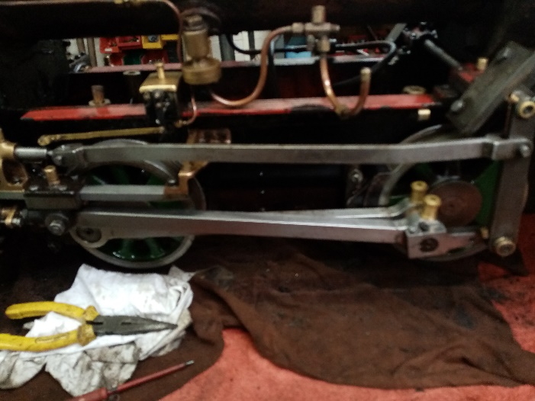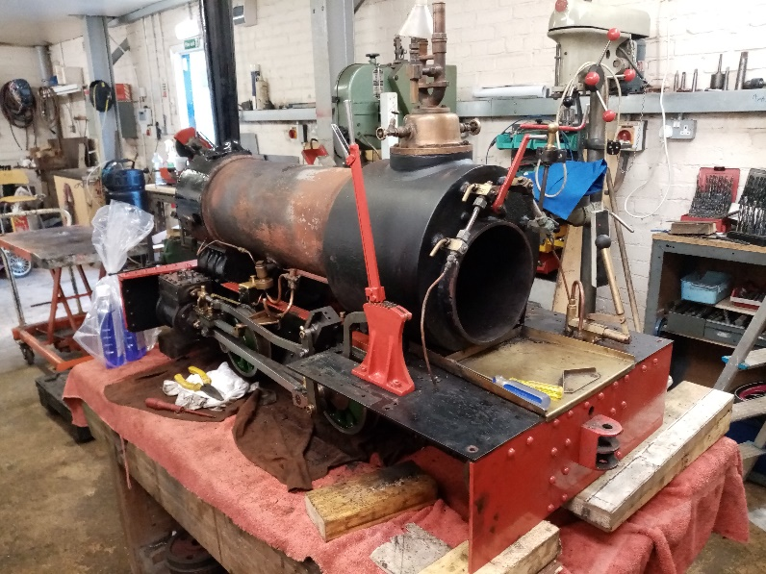

Cleaning of the wheels and frames started. Eva with Saddle tank and cab removed. Boiler almost ready to
lift out of the frames.

Kind Regards
Ian

