STRATHAVEN MODEL SOCIETY Ltd

Registered Office and Clubrooms Company Secretary
2 Dunlop Street
Strathaven 2 Dunlop Street
South Lanarkshire Strathaven
ML10 6LA South Lanarkshire
ML10 6LA

Email:strathavenminiaturerailway@gmail.com
Web address: - www.strathavenminiaturerailway.org
- Facebook.com/strathavenminiaturerailway

News Letter December 2020

Keep Safe and Well Hopefully we will see a vaccine rolled out soon.

Dear Member
Members Information

Workshop remains closed through Tier 3 to all members out with the team working on Eva and the raised track sections. Only essential work being carried out by a limited number of members (4) on a Monday and Tuesday night. As is normal workshop closed throughout the festive break and re-opens 4th of January.
As we approach Christmas and the holiday season, it will not be the same as usual. No Christmas lunch and get together for us this year. It appears that all our members are keeping Covid free so far this year. We have a few members with different illnesses or aches and pains but we are all still keeping going. Hopefully we can start seeing more of each other in the New Year and when Tier reductions will allow members to get back to the workshop and the park to complete the winter work list (see attached update).
Our new season start is planned for the 27th of March 2021 (17 weeks for those who are counting). To those attending the workshop now on a Monday or Tuesday evening we should all be wearing a face covering if more than TWO members are in the workshop at any one time.

Park & Kiosk
During November several of the winter tasks have been completed - all of the ground track carriages checked over and grease applied to all the bogies along with all the airlines being checked and tested (15 minutes per individual carriage - no air leaks found and the same for two sets of three); Strathaven Castle fully serviced with just a couple of small items to be completed on her; Eva’s tender and S. C. airlines tested and passed; Abberton tender has several airleaks which will need to be resolved along with her annual service; Margaret complete service carried out now oiled up ready for spring.
Our new (second hand) Class 67 5”guage is now in the kiosk at the park. This locomotive is battery operated by two 12V batteries driving all eight wheels. We are planning for this loco to be used on the ground and the raised tracks to encourage junior member participation and develop a new membership base for the future. See pictures at the end of the newsletter.
At present it looks like the way we finished this year’s running season with us all in face coverings, using sanitisers and wipes along with social distancing, will be the way we start the 2021 running season. Fingers crossed that this will not be for the full sesson and that we get back to some normality with Gala Day and the Balloon Festival being able to take place again in the park.

WORKSHOP & Raised Track
Fiona, our 5” saddle tank, successfully passed her steam test in November with two injectors and a hand pump now supplying water to the boiler. Some minor pipe work on the tender will require work to stop air ingress when using the injectors. She can then be taken to the park in the spring for members to use and develop their steam driving skills.
Eva is now ready for her tubes to be withdrawn from the boiler in the very near future. New tubes arrived from the supplier this week and at a fraction of the initial cost estimate (£156 supplied and delivered) for 32 tubes all to EN standards. Also a tube expander has been purchased especially for this task which will make installation of tubes more straight forward. David W., who is painting the cab and and the saddle tank, reports good progress has been made and that he will be ready to start painting the tender at the start of next year.
We started to look at the raised track in the yard of the workshop this week and are planning on fitting the fish plates to these sections. On counting all the sections before starting this we have discovered we are two curved section short of what is required. We have the lengths of track pre-drilled and they now just need to be made up, then we can start fitting the plates. Each section to be numbered in sequence ready for transporting to the park in the spring, this will ensure a good fit of each section to the next.

Dates for your DIARY 2021

First running day of the 2021 season we are planning it to be Saturday the 27th of March. This will let us evaluate all the winter work carried out ready for Easter weekend 3rd 4th and 5th of April 2021.

Our splendid new ‘Royal Sovereign’ Locomotive
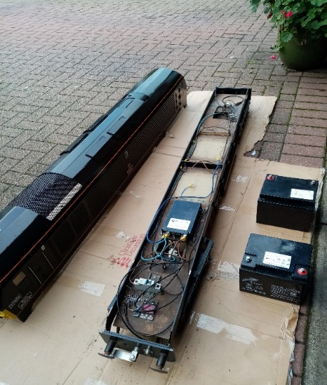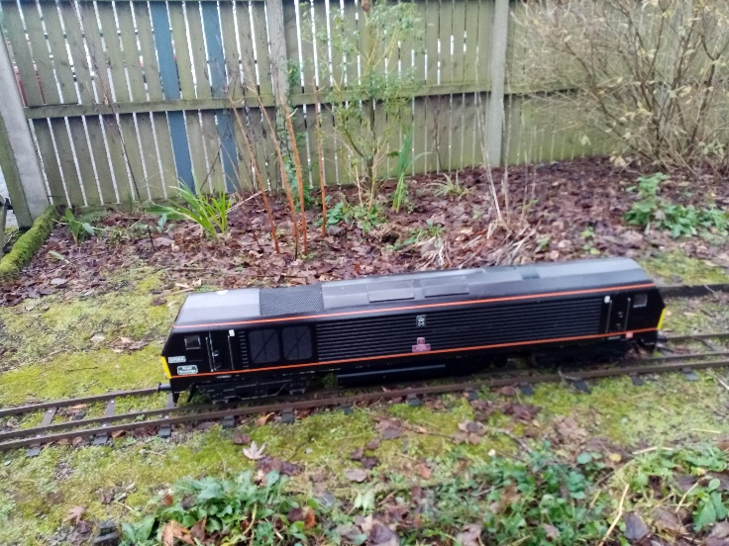

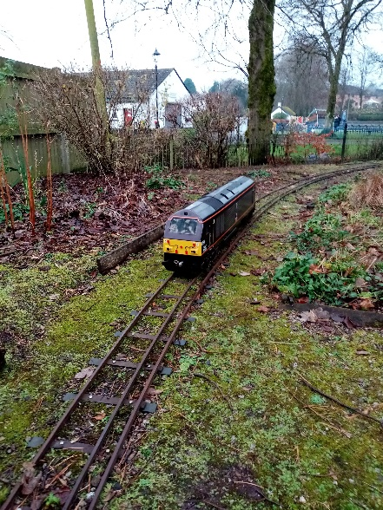
The locomotive is just short of six feet in length. Picture of batteries and chassis with body off. One man can lift each of the pieces but as a complete loco will require two when lifting is required. Hand controller can be plugged in just under the buffer beam.

Kind Regards
Ian

