STRATHAVEN MODEL SOCIETY Ltd
Registered Office and Clubrooms Company Secretary
2 Dunlop Street
Strathaven 2 Dunlop Street
South Lanarkshire Strathaven
ML10 6LA South Lanarkshire
ML10 6LA
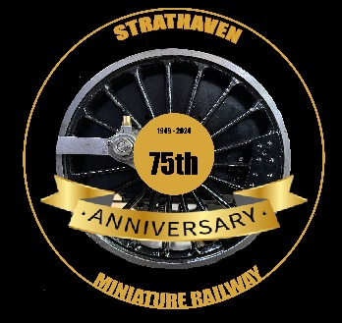
Email:strathavenminiaturerailway@gmail.com
www.strathavenminiaturerailway.org
Facebook.com/strathavenminiaturerailway
Facebook.com/StrathavenModelSociety
News Letter Anniversary Celebrations November 2024

Dear Member

Members Information
During November, Jay attended a dinner on behalf of the society in Burnside, where we were presented with a certificate for raising over £750 for the Kilbryde Hospice during the summer. The total amount raised this year by our Provost Margaret C for this charity was over £75,000. See photograph at end of newsletter. From now till the Spring our focus will be on our large winter list and of course the new carriages that need to be set up with airbrakes to our requirements.

The workshop will close throughout the Christmas and New Year break for formal work, if any member who has a key and wish to enter the workshop over the holiday period they can do so. Our last get together for club work is the 19th of December and we will restart work on the winter list on the 6th of January.

Park
In the park the kiosk has now been closed down for the winter, with the water turned off at the mains valve. All locos have been drained of water and the heating has been put on in both the kiosk and container two. The track from container one needs to be completed for the 5” track ready for 2025. Space has been started to be made in container 2 ready for the third track to be installed and then decide on the best way to join the container tracks to the main line. When there is any good weather in the New Year we will service all the locomotives ready for the new start in 2025 at present 5th of April will be the start of the new season.

Workshop
The workshop is a hive of activity at present with work progressing on several fronts, main focus is on the Black 5, cladding will be fitted to the fire box and the boiler over the coming months. Work is now focused on the tender where a water tank will need to be installed and all the plumbing fitted to feed the injectors, axle pumps and the hand pump (this will be an electric pump). Pieces are still being fitted to the locomotive which is looking more like an engine as each week progresses. A big thank you to Mike, Tom and the others who are assisting with this large project.
On Monday the first of our new carriages also entered the workshop and was put up on trellises. Once the bogies are attached to each end of the unit they are a lot heavier than we initially thought. The side has been taken off the carriage and we have commenced working out the best places to locate the air cylinder in each carriage plus the airline system that will operate the brakes in the future. Instead of a disc brake as in the past these bogies are fitted with brake shoes on each of the four wheels on each bogie.

Our annual winter work list is now published with all the usual work required to be completed on all rolling stock and locomotives in all gauges. The main work in the workshop for this winter will be the six new passenger carriages which require fitting out to comply with our requirements for a compatible braking system and to ensure they will be ready for the new season.

Additional Info
Club running days for members (Track can be used at any time by members except ground track on running days) for 2025 will be published in January, but they are normally the 1st Monday or nearest available Thursday of the month, to allow members to familiarise themselves with club locos for running days. This is also a time for members who wish to run their own locos while other members are in attendance.
Both ground and raised track can be used at any time by members, ground track restricted when passenger hauling.

Kind Regards
Ian

