STRATHAVEN MODEL SOCIETY Ltd
Registered Office and Clubrooms Company Secretary
2 Dunlop Street
Strathaven 2 Dunlop Street
South Lanarkshire Strathaven
ML10 6LA South Lanarkshire
ML10 6LA
Email:strathavenminiaturerailway@gmail.com
www.strathavenminiaturerailway.org
Facebook.com/strathavenminiaturerailway
Facebook.com/strathavenmodelsociety

*A HAPPY & HEALTHY NEW YEAR TO ALL OUR MEMBERS AND THEIR FAMILIES. *

Dear Member
Members Information
We start 2025 with 59 senior members (2024 = 51) and 24 juniors (up from 18 last year). We need help now over the next seven weeks or so before the new season starts with repairs and testing of rolling stock etc., suitable for all levels of skills either in the workshop or in the park when the weather allows. Please if you are available on a Monday or Thursday over the next few weeks, come along to assist with the work to have everything ready for the new season.
Season commences 29/30th of March this year.

Christmas Lunch
It seems like a long time ago but it was just last month. An enjoyable lunch was had by all who attended.

Park
As the weather improves, hopefully, over the next few weeks, we will need to focus on the work required to be completed ready for the new season. We will also look at adding a fourth track into container one for our dual purpose 5” carriages to make it easier to get them out. This will involve making a new bridge from the container plus a rail being added to the 7¼” to give us a five-inch track from container one to the ground track. Some of this work has been completed with the new S shaped bridge track added to the 7¼” track from the container. The last piece of the jigsaw will be the additional work required to add the 5” track to the swing points from container to mainline. Thanks to Gordon for all the work he has been putting in on this task. Gordon hard at work below.
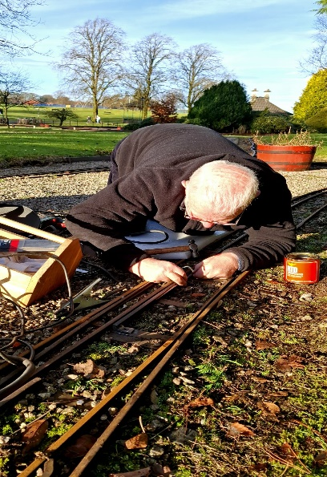

Workshop
The workshop is a hive of activity at present with the work progressing on the Black 5 shifted to the tender and with fitting out almost complete, final fettling and checking all water connections are aligned.
Other work has mainly focused on the new carriages in the workshop with the airlines and tanks being fitted along with the brakes mechanisms.
Photos down below of the interior of these carriages as they are being fitted out.

Additional or special dates for your diaries over and above normal weekend running April//October
Monday 24th March - test day for rolling stock and locomotives before new season commences.
Saturday 29th March - first running day of the new season.
Sunday 30st March – Mothers’ Day
Saturday 19th April - Easter Saturday
Sunday 20th April - Easter Sunday
Monday 21st April - Easter Monday
Monday 5th May - Bank holiday
Wednesday 14th May - 76 years of S.M.S. running in the park.
Monday 26th May - Bank holiday
Friday 13th June- Duck race in the park - Running from 4.00pm to 8.00 pm
Saturday 14th June - GALA DAY
Sunday 15th June – Fathers’ Day
Monday 21st July - Glasgow Fair holiday
Friday 22nd August - Balloon Festival Evening (16.00 – 21.00)
Saturday 23rd August - Balloon Festival All Day Running
Sunday 24th August - Balloon Festival All Day Running
Saturday 27th September - September weekend holiday
Sunday 28th September - September weekend holiday
Monday 29th September - September weekend holiday
Any running after this date in the park would be donations only
Saturday 11th October - Club Open Weekend - No public running
Sunday 12th October - Club Open Weekend - No public running
Saturday 8th November - GUY FAWKES LATE AFTERNOON/EVENING RUNNING

Track can be used at any time by members except ground track on running days

Kind Regards
Ian

