STRATHAVEN MODEL SOCIETY Ltd
Registered Office and Clubrooms Company Secretary
2 Dunlop Street
Strathaven 2 Dunlop Street
South Lanarkshire Strathaven
ML10 6LA South Lanarkshire
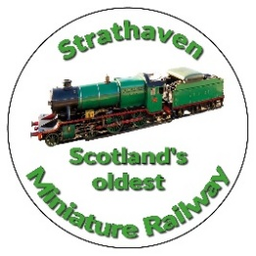
ML10 6LA
Email:strathavenminiaturerailway@gmail.com
www.strathavenminiaturerailway.org
Facebook.com/strathavenminiaturerailway
Facebook.com/strathavenmodelsociety

News Letter February 2025
Dear Member
Members Information
During January we had three new members join the society please welcome them as and when you meet them at the park or the workshop. They are Peter Bakke (Friend of Simon H and will travel down with him when they can), John Fallon G scale enthusiast and ex member of ESME (Livingston) and John Emley (Full time main line driver). We urgently require abled bodies members to assist with the winter work list or we will not be ready for the new season at the end of March. Repairs and testing of rolling stock etc., suitable for all levels of skills either in the workshop or in the park when the weather allows. If you are unsure what you can help with come along and shadow one of the team and see if you can assist with this vital work. Come to the workshop first on a Monday or Thursday and depending on weather we will work on the list attached. This season commences 29/30th March this year if all work completed on time.
Date for your diary the AGM this year will be held on Tuesday the 15th April in the sports pavilion in the park at 19.00hrs.

Park
As the weather improves, hopefully, over the next few weeks we will need to focus on the work required to be completed ready for the new season. Gordon has completed the work at container one with the new pieces rail to complete the 5” points from the siding onto mainline, also the mainline 7¼” track has been cut to allow both guages to run through the points at the container. They will need a final weld to complete all this work (Thank you Gordon). This will now allow us to run the 5” dual purpose carriages out of the container without having to lift them over the 7¼” carriages. Last week we took the first 3 of the new carriages (Nos 1, 2,& 3) to the park, coupled them up and pushed them around the track checking points and curves with the new rolling stock, happy to say the performed well. They need final work to be completed, an upgrade to the braking systems, to allow them free to roam on our mainline. Thanks to Ian Mc D for machining these new parts, which will be retro fitted to the carriages in the park, along with fittimng them to the 3 other carriages in the workshop at present, as standard modifications. Thanks to all assisting with the above work.

Workshop
The workshop continues to be a hive of activity at present with work progressing on:
- the 3 remaining carriages - led by Jay and Ian McD, Jim L, Angus and others - all going well they will be completed by this month end
- Black 5 - Mike and Tom McI are concentrating on all the water connections required on the tender and finishing the internal water tank for the tender - Angus has been working on how to install an electric water pump, complimenting the traditional axle pump and steam injectors - the boiler still requires its cladding and outer casing to be fitted - thereafter pony wheels to be fitted along with the top half of the smoke box casing
- Steam test of Cairnhill, the 15xx Speedy - requires to be completed on the first dry day in the yard.

Additional or special dates for your diaries over and above normal weekend running April//October
Monday 24th March - test day for rolling stock and locomotives before new season commences
Saturday 29th March 2025 - first running day of the new season
Sunday 30st March - Mother’s Day
Saturday 19th April - Easter Saturday
Sunday 20th April - Easter Sunday
Monday 21st - April Easter Monday
Monday 5th May - Bank holiday
Wednesday 14th May - 76 years of S.M.S. running in the park.
Monday 26th May - Bank holiday
Friday 13th June - Duck race in the park - Running from 16:00 to 20:00
Saturday 14th June - GALA DAY
Sunday 15th June - Father’s Day
Monday 21st July - Glasgow Fair holiday Monday
Friday 22nd August - Balloon Festival Evening (16:00 – 21:00)
Saturday 23rd August Balloon Festival - All Day Running (09:00 to 21:00 weather dependant)
Sunday 24th August Balloon Festival - All Day Running (09:00 to 21:00 weather dependant)
Saturday 27th September - September weekend holiday
Sunday 28th September - September weekend holiday
Monday 29th September - September weekend holiday (Any running after this date in the park would be donations only)
Saturday 11th October - Club Open Weekend (No public running)
Sunday 12th October - Club Open Weekend (No public running)
Saturday 8th November - GUY FAWKES LATE AFTERNOON/EVENING RUNNING (16:00 to 21:00)
(Track can be used at any time by members except ground track on running days)

FIRST RUNNING DAY for passenger hauling 2025 Saturday 29th March

Kind Regards
Ian

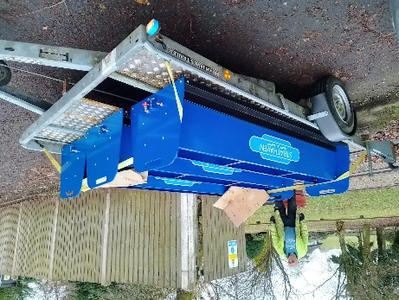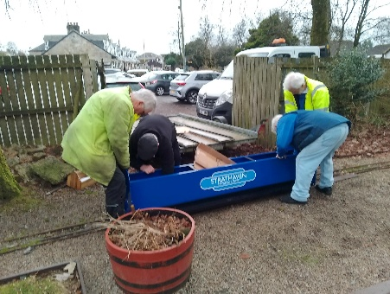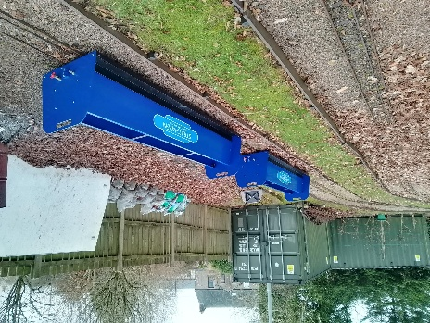
Arrival at the park Placing them on the track Ready to be connected

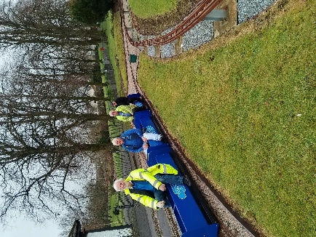 Padded seats still to be installed . 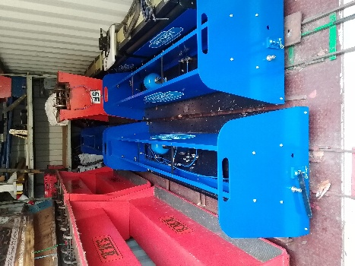
Test push round track First three In the container

