STRATHAVEN MODEL SOCIETY Ltd
Registered Office and Clubrooms Secretary
2 Dunlop Street
Strathaven 2 Dunlop Street
South Lanarkshire Strathaven
ML10 6LA South Lanarkshire
Email:strathavenminiaturerailway@gmail.com
www.strathavenminiaturerailway.org
Facebook.com/strathavenminiaturerailway
Facebook.com/strathavenmodelsociety

ML10 6LA

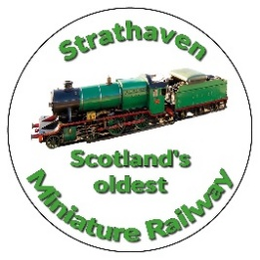

News Letter June + July 2025
Dear Member

Members Information
Thank you to the members who are out on a regular basis to assist with operating the trains over the last two months. The weather has been poor and on many a time over the last two months and we have been rained off after only running for an hour or two. Hopefully August will be a better month for us. Mike, Tom and Eric have been the stalwarts in the work shop over the summer months and we can see major steps forward with the Black 5.
Juniors are regularly attending their classes on a Tuesday night now. This year’s intake have all shown good interest in the classes plus, of course, getting to drive a loco later after the class work. We will hold the Juniors funday on the afternoon of the 12th of August this year.

Park
Over the two months of June and July we had our Gala Day running and in June the Glasgow Fair Monday holiday running which normally boosts our numbers during these months. With the weather being so mixed any gains we did make were lost on other days due to weather. Over the 23 running days so far we had six where we carried less than 60 passengers and one completely rained off day with 0. Over the two months our passenger numbers were June 1784 and July 2346 and a running total for the first four months 11,483 which is actually the third best four months to the start a year in the last 10 years. April and May were both extremely good months which has made all the difference. In June + July we also sold 90 and 100 badges respectively, with a year to date running total now of 635.
Later this month (August) we will hopefully have the Balloon festival over the three days of 22nd 23rd and 24th which can be a massive boost to our income if the weather is kind to us and we have enough volunteers for these two days and an evening to carry the number of people who visit the park at this time.
We have been using most of our locos at the park now, in some cases starting the day with battery power and switching to petrol later in the day. This has given those who are out on running days the chance to use all of the engines that we have in the park. We have been rather frugal with our steam locos and have used them infrequently over this time, the weather did not help as it is easier to turn on a petrol or battery loco than getting steam up, ready to run, with little or no passengers to haul. We have been finding that three of the new carriages on most days can cope with the amount of visitors to the railway as they can carry at least 4-5 more passengers per journey. It is not unusual to have 18 passengers on the three carriages (mixed adults and children). Once again thank you to all who have assisted on our running days. Angus, Jim and others have been out on a Thursday recently over the school holidays and have run a loco with two carriages and this helped to boost the running total for July.

Workshop
At the end of June + start of July we hired a skip for a week to clear out stuff from the yard, workshop area and some stuff from the park. This has given us more space in the kiosk, containers and the workshop, please do not bring anything into these places as a ‘just in case we may need it in the future’. Speak to one of the workshop team if you are thinking of donating anything as we do not want to end up with as much stuff as we had before the clearance took place.
Work progresses with the Black 5 and Mike and Tom are now at the stage of covering the cladding with brass sheeting on both the boiler and firebox, this is a slow process to make sure it is correct and will affect the look of the loco once painted. In the last few days, the covers for the cylinders have been made and the hand rails along the side of the boiler have been cut ready for fixing. Thoughts have turned to the name of the loco and one or two suggestions have come to the fore. Of all of the Black 5s built (842) only 4 were ever given a name, one of which was ‘Glasgow Highlander’, another suggestion which is more a local choice could be ‘Covananter’, we will decide on the this later in the year if we do give the loco a name and number. Margaret was given the number 1949 which no loco of this type ever carried as it is the year of completion by the two builders, therefore if the Black5 is completed this year it could be numbered 2025, or 2026 if it takes in to next year to finish.

Additional or special dates for your diaries over and above normal weekend running August/October
Tuesday 12th August - Junior Fun Day - afternoon, see separate email to parents.
Friday 22nd August - Balloon Festival Evening (16:00 – 21:00)
Saturday 23rd August - Balloon Festival All Day Running (09.00 to 21.00 weather dependant)
Sunday 24th August - Balloon Festival All Day Running (09:00 to 21:00 hrs weather dependant)
Saturday 27th September - September weekend holiday
Sunday 28th September - September weekend holiday
Monday 29th September - September weekend holiday
Any running after this date in the park would be donations only
Saturday 11th October - Club Open Weekend - No public running
Sunday 12th October - Club Open Weekend - No public running
Saturday 8th November - GUY FAWKES LATE AFTERNOON/EVENING RUNNING (16:00-21:00)

Track can be used at any time by members except ground track on running days

Kind Regards
Ian

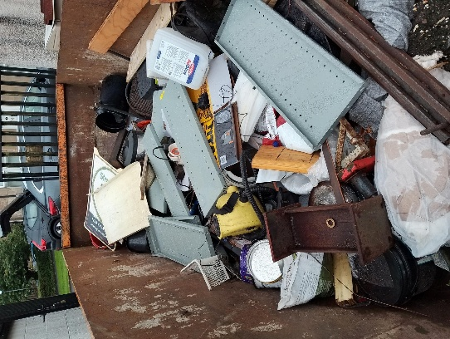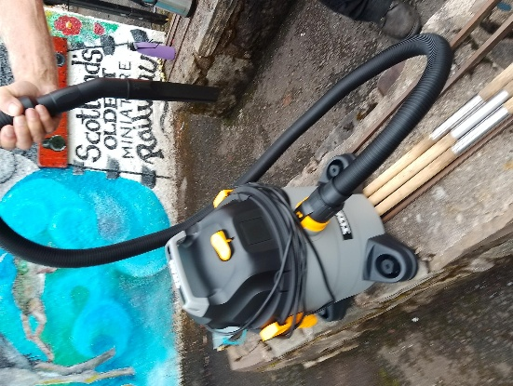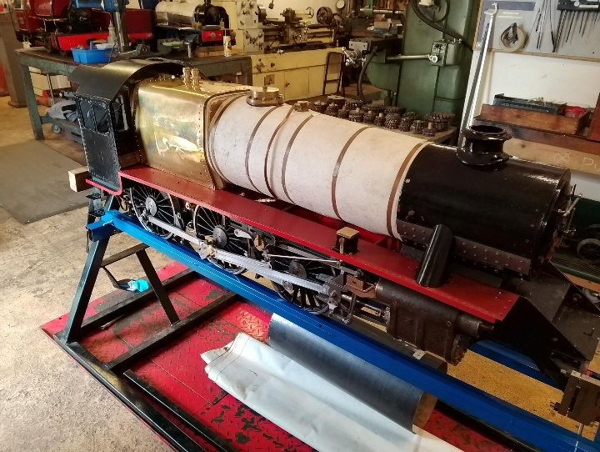

Skip being filled New vacuums - one in the park and the other in the workshop Cladding on firebox

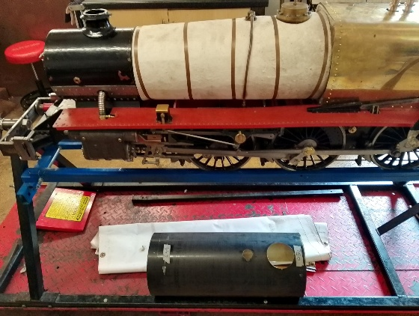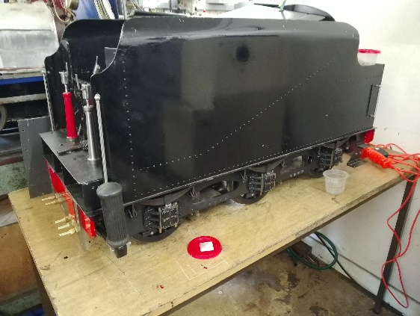

Brass barrel rolled now under loco ready for fitting Tender for Black 5 now being with an electric pump to feed the boiler
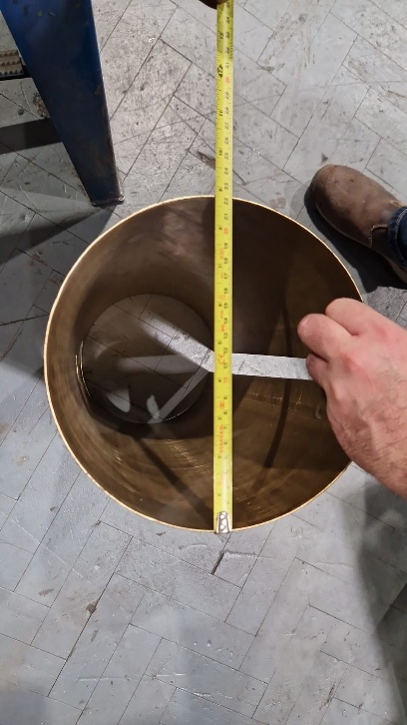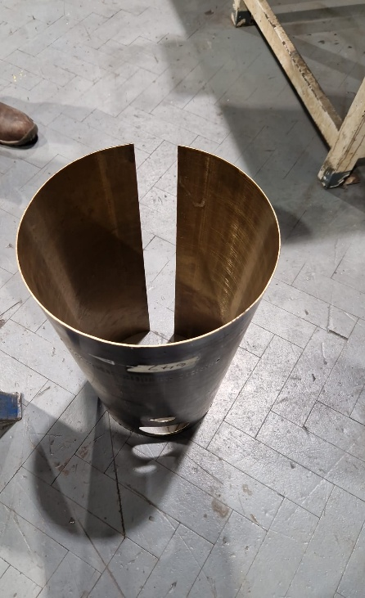
Thank you to Strathclyde University for rolling the large piece of brass that will clad the boiler of the Black 5

