STRATHAVEN MODEL SOCIETY Ltd
Registered Office and Clubrooms Company Secretary
2 Dunlop Street
Strathaven 2 Dunlop Street
South Lanarkshire Strathaven
ML10 6LA South Lanarkshire
ML10 6LA
Email:strathavenminiaturerailway@gmail.com
www.strathavenminiaturerailway.org
Facebook.com/strathavenminiaturerailway
Facebook.com/strathavenmodelsociety

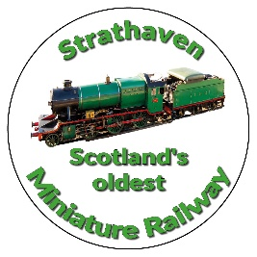

News Letter August 2025
Dear Member

Members Information
Update on some of our members who have been ill during the month. Graham P is back in hospital and still under investigation for heart issues. Some of our other members with long term illnesses are dealing with the medication and side effects (unfortunately). Tom A had a trip in the park where he stumbled over the track edge whilst helping with others on track levelling work just after the diamond, he suffered a cut eyebrow and a heavy blow to the head., after attending hospital he was allowed home and since then he has been back to the park just recently, sporting a black eye, but well on the way to a full recovery. Several of our members visited Leyland open track weekend at the end of the month where an enjoyable gathering was had by all. The next open track meeting is at Vogrie 39th ANNIVERSARY OPEN TRACK & BBQ on Sunday 5th. Oct. 2O25 NOON TO EVENING, the address is Vogrie Country Park Railway, EH23 4NU, at present several members have intimated attending this event.

Park
Thank you to all who volunteered for the Balloon Festival this year. After the disappointment of the 2024 festival being cancelled due to the adverse weather the 2025 festival went ahead as scheduled except for the sky diving which was cancelled due to the low cloud ceiling.
Over the two and half days of the 2025 festival we had A RECORD WEEKEND.
See the table below of how we smashed all the records of previous years (highest one day, highest overall festival).

YEAR 2025 | Tickets per day | Year 2023 | Tickets per Day | Year 2022 | Tickets per day
Friday | 153 | Friday | 244 | Friday | 140
Saturday | 2217 New record day | Saturday | 1884 new record day | Saturday | 1495
Sunday | 2167 almost beat the record | Sunday | 1464 | Sunday | 1742 old day record
Total | 4537 Record for the Balloon Festival | Total | 3592 | Total | 3377
Badges August | 249 | Badges August | 410 | Badges  August | 155

On Saturday and Sunday, we ran with three sets of three carriages, two blue sets and one set of our red carriages. The new blue carriages were amazing in that they could carry so many more passengers at one time and not affect the efficiency of the locos pulling them. At one time Jim L reckoned that we were carrying 18-21 passengers per train load. On the Sunday after a slow start and repair carried out to the track by Jay, we kept three trains running from lunchtime onwards and still the queue was half way up to the main road.
Thank you again to all who assisted in this major undertaking.

An update from Jay regarding finances at the end of August - we are massively in the black after the Balloon Festival. After extracting the Balloon festival figures, we were still in Black with September numbers still to be added to our running totals. Our last fund-raising night will be guy Fawkes where we can generate in excess of £500 in just one night if the weather is good. Therefore, our society is well funded and we are now looking at what this money can be used for, which will benefit our membership.

Workshop
Work continues in the workshop on the Black 5 (see pictures below of cladding now being fitted to fire box, boiler and the cylinders). The pony wheel is having some last-minute work done before being fitted. We are now waiting for a delivery of an extra-long hydraulic table that will accommodate the Black 5 loco without it hanging of the end of the table. This is due for delivery late September.
In the meantime, work has started on Fiona, our 5” Sweet Pea locomotive, both pistons have been removed from the cylinders and two new piston rings have been made by Tom McI. At the same time the wheels that had slipped on the axles will now be refixed in place and the timing checked before re-assembly. This will allow for Fiona to be taken to the park and it can then be used by club members.

Additional or special dates for your diaries over and above normal weekend running September/October

Saturday 27th September - September weekend holiday
Sunday 28th September - September weekend holiday
Monday 29th September - September weekend holiday
Tuesday the 30th of September Last JUNIOR Session, if we do any thing during the school holidays in October we will announce this nearer the time.
Any running after this date in the park would be donations only
Saturday 11th October - Club Open Weekend - No public running
Sunday 12th October - Club Open Weekend - No public running
Saturday 8th November - GUY FAWKES LATE AFTERNOON/EVENING RUNNING (16:00-21:00)

(Track can be used at any time by members except ground track on running days)

Kind Regards
Ian

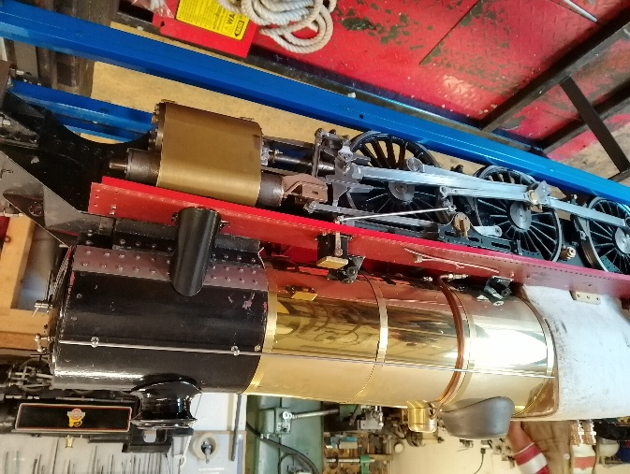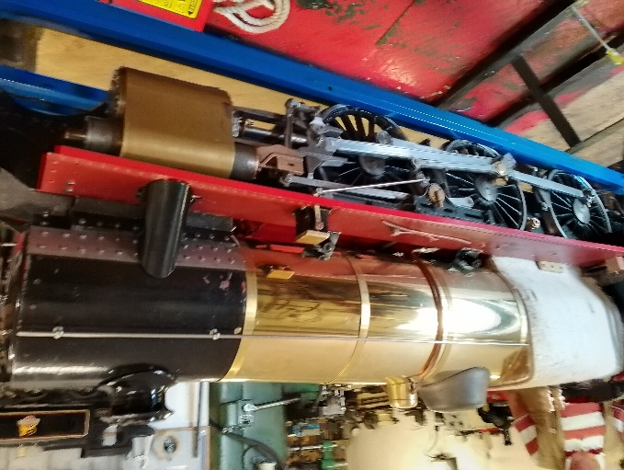
Cladding on Boiler and Cylinders
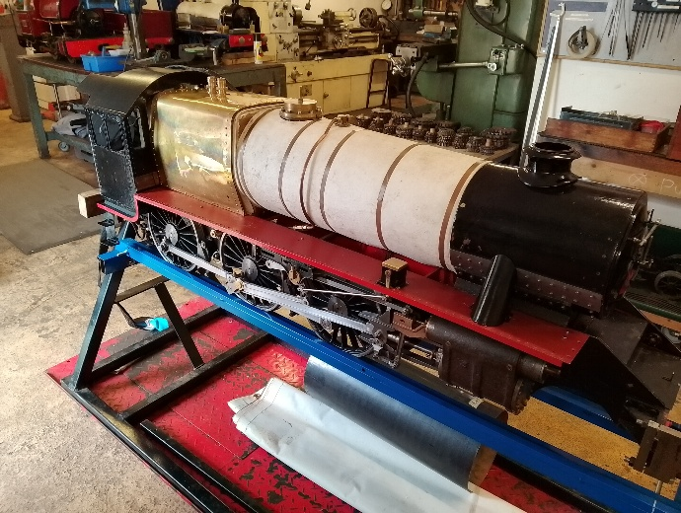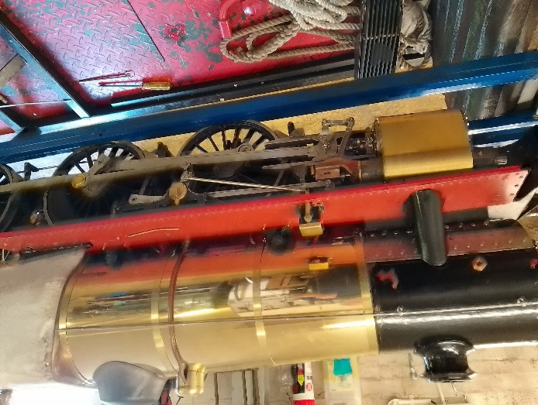
Cladding on Firebox , Cylinders and Boiler

