STRATHAVEN MODEL SOCIETY Ltd
Registered Office and Clubrooms Company Secretary
2 Dunlop Street
Strathaven 2 Dunlop Street
South Lanarkshire Strathaven
ML10 6LA South Lanarkshire
ML10 6LA
Email:strathavenminiaturerailway@gmail.com
www.strathavenminiaturerailway.org
Facebook.com/strathavenminiaturerailway
Facebook.com/strathavenmodelsociety

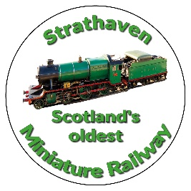

News Letter September 2025
Dear Member

Members Information
Several members, including myself, are attending hospital this month please wish them well and we hope the medical teams can get to the bottom of the issues concerning each of our members.
Unfortunately, the Vogrie OPEN TRACK & BBQ Sunday 5th Oct 2O25, EH23 4NU had to be cancelled after advice from the country park staff.
Remember this weekend is our own Open Track weekend on both Saturday and Sunday (11th and 12th of October) all day running from 09.30 through to early evening. Catering as usual will be provided by the Tudor in Strathaven. If you can bring along cake or biscuits to supplement the food from the Tudor, that would be great, please take it to the pavilion at some time during the day.
Junior section held their last night for this season on Tuesday the 30th Sept with nearly all members in attendance. A big thank you to all the parents who have brought their children along to the park with such regular attendance.
An even bigger thank you to Jim L, Jay H, Duane & Heather D, Randy F who have assisted in set up and where applicable helped with each of the classes. Other members have assisted as and when available. Nathaniel F and Rory S, were the top performers in their respective groups, but all of the boys and girls have come on leaps and bounds this year. Thank you, junior members, for keeping calm and collected while attending the classes.

Park
Congratulations everyone who has assisted at the park or our back up from an engineering perspective in the workshop. Since 1949 we have had three main track layouts over the years. The initial 400-foot oval which was more or less in the area of the old, raised track. Then we had a large one-track loop until we changed that to what we have today, laid in 1998/9. Over the time there have been landmark days for each of these tracks regarding numbers of passengers carried. The highest number of passengers carried until this year was in 1992 when we managed to carry 20,812 passengers according to ticket sales. In 2025 we now have a new record with 21,112 tickets sold throughout the season, a great job by everyone. Our badge sales for 2025 were £966.00.
Following a committee meeting 6th Oct, we have several projects in mind for the benefit of our society members, once pricing and availability have been confirmed we will share this information with all members, especially around loading and unloading of locos from vehicles to track.
See photographs at end of newsletter. We have negotiated with the supplier to make a bespoke hydraulic table,
instead of nylon wheels ours will have solid rubber units, the table is just over two meters in length with extending locking bars that can reach into a car/van/trailer and allow for ease of off-loading. Instead of just 7¼ rails we will have an extra installation to allow 5” locos to be unloaded. This will be with us for the start of the new season delivery late Feb/ March. The table height range will be from approx. 12” at its lowest to around 3 feet at it’s highest, that should allow most people to unload without lifting the loco.
This will be in the park at the kiosk end; we are looking at ways of locking it in situ when not in use. It is envisaged that we will cut part of the fence next to the kiosk and make a swing gate allowing for offloading from vehicles to come through the existing gate and then the new gate straight to the first steaming bay.

We have had some issues with derailments of our new carriages, i.e. three incidents in the last month. We have taken this up with Abbot Model Engineering and have had two or three in-depth discussions with them. As of 6th October, Abbot will be supplying us with 24 sets of prototype frames for our bogies to replace all of those on each of our carriages. The new side frames will be stronger and shaped differently from the original ones; they will also come with an upgraded re-railer system which we do not have at present. The new material will be with us around the 12th of October. These upgrades will be supplied at no cost to us; all we need to do is replace the components on our existing units.
It was suggested that we could move to larger wheel units instead of what we have, unfortunately this does not appear to be feasible.
Two main reasons:
Firstly: They would lift the carriage up by approx. 2inches (50mm) thus raising the centre of gravity and possibly cause carriages to tip over more easily. Tipping of carriage could also occur when we are loading or unloading passengers as they could stand on running board and as the wagon is higher there is more possibility of rolling over (this happened with the old red carriages).
Secondly: If the carriages are higher, then we have the possibility of feet being able to go under the carriage and causing injury to a passenger. At present the carriages are very close to the ground making it extremely difficult to put feet under the rolling stock.
The committee will work on this topic with AME and report back on the changes they have engineered.

Workshop
We await delivery of our new hydraulic table, due 2nd week of October, which has been held up by one week. This unit will be able to take the Black 5 without the loco hanging off the end of the table.
It is hoped to remove the Black 5 from its cradle shortly and then prepare it for its first steam test in the yard. Progress has also been made on both Fiona and Holmside, the later ready to be run on air and, if successful, cab and saddle tank can be refitted before a steam test is then carried out with all fittings in place.
A big thank you to Mike, Tom and Eric and others for the work being carried out on these three locos.

Additional or special dates for your diaries over and above normal weekend running

Saturday 11th October - Club Open Weekend - No public running
Sunday 12th October - Club Open Weekend - No public running
If we do any running during the school holidays in October we will announce this nearer the time.
PLEASE NOTE CHANGE OF DATE FOR GUY FAWKES NIGHT RUNNING.
Saturday 1st of November GUY FAWKES LATE AFTERNOON/EVENING RUNNING (16.00 -21.00)

(Track can be used at any time by members except ground track on running days)

Kind Regards
Ian

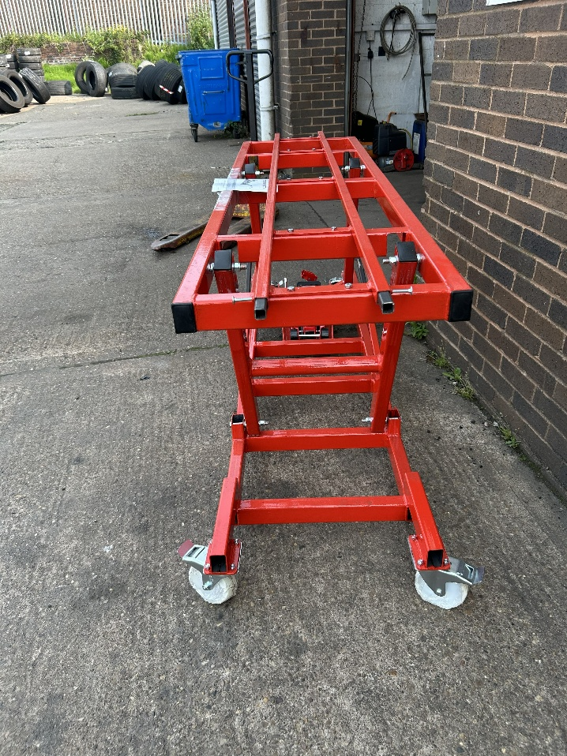
You can see the black extending bars in this picture, they lock in place while in use and can be stored back in the table when not in use, they are installed at both ends. Wheels will be solid rubber not as shown in the picture.

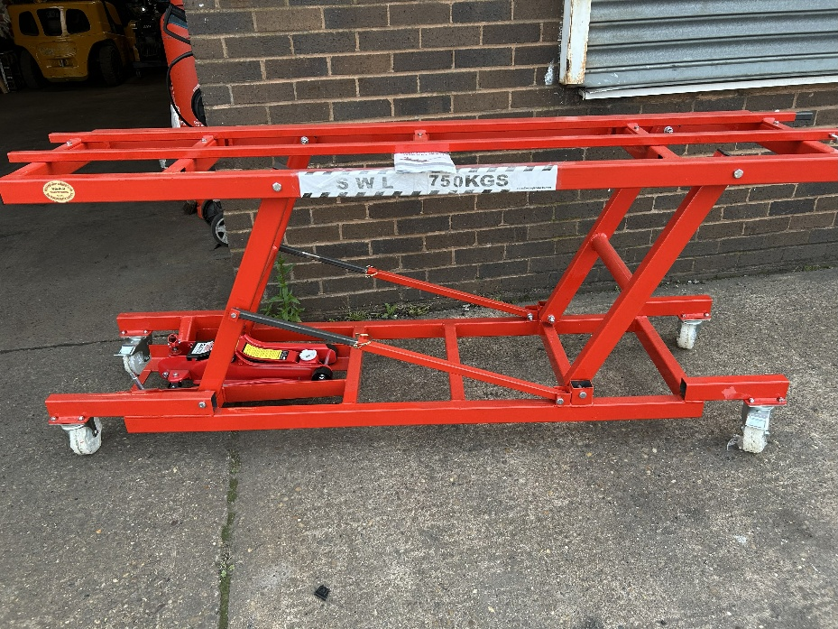

Side view. It has the capacity to take nearly all locomotives under 750 kg.
This will take the Black 5 or Margaret or similar without having to disconnect the tender.

