STRATHAVEN MODEL SOCIETY Ltd
Registered Office and Clubrooms Company Secretary
2 Dunlop Street
Strathaven 2 Dunlop Street
South Lanarkshire Strathaven
ML10 6LA South Lanarkshire
ML10 6LA
Email:strathavenminiaturerailway@gmail.com
www.strathavenminiaturerailway.org
Facebook.com/strathavenminiaturerailway
Facebook.com/strathavenmodelsociety

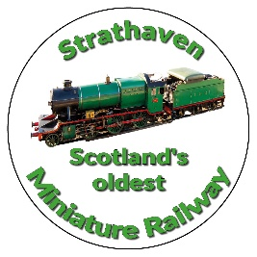
News Letter January 2026

*A HAPPY & HEALTHY NEW YEAR TO ALL OUR MEMBERS AND THEIR FAMILIES. *
Dear Member
Members Information
As 2025 finishes we end the year in a healthy position both in monetary and membership. After some major expenditure throughout the year, mainly at Dunlop Street, we will break even or have a small surplus. As for membership we will end the year with 4 more senior members (55 in total) and we now have 25 juniors plus three from 2024.
We have several members still attending hospital at present but all are making progress after surgery or new treatment.
Our Christmas lunch, which was held at the Strathaven Hotel on 16th Dec 25, was another great success according to the feedback from the members attending, it was good to see some of our newer members being able to attend this annual event.
At the start of 2026 one of the first telephone calls I received was to let me know and the membership that Kenny Johnstone had passed away, suddenly in his sleep between 1st and 2nd of January. More details regarding arrangements to follow once the family have the information to share. Please keep Kenny’s sister in your thoughts.

Park
The winter work list has now been published, WHAT CAN YOU DO TO ASSIST WITH THIS?
The kiosk has had issues with the back door which is proving difficult to close or open. We are also having issues with water ingress through the roof. I have reported this to SLC who have said they will look into these repairs that we require to keep us wind and water tight. Heating has been put on in the kiosk and the containers, hopefully this will keep rolling stock and locos safe over the winter. Water has also been turned off at the kiosk.
Neptune required a new gear wheel to be fitted to the rear bogie which has now been received and is ready to be re-installed on the loco. We are looking at some kind of wire mesh to be fitted on the rear bogie which could protect the rear wheel gearing from stones being thrown up into the mechanism.
Track work and locomotive servicing will be the priority after the new year break.

Workshop
Work continued in the workshop right up to the last possible day to re-assemble the Black 5 after it had been found that she had several issues with water leaks from different locations, key area of concern was in the smoke box where special parts were made to seal the regulator before refitting super heaters. On the last day in the workshop loco reassembled, put under pressure for hydraulic test, and passed the retest at + 50% of working pressure. Now ready for steam test. The tender also has some issues when filled with water, final last tweaks to be completed this month and then she will also be ready for working with the loco.
Work also commenced on Maldwyn repacking of cylinder glands.

Additional or special dates for your diaries over and above normal weekend running April//October

New season starts on the 28th^{th} of March one week before the Easter weekend
April 3rd Easter Saturday
April 4th Easter Sunday
April 5th Easter Monday

(Track can be used at any time by members except ground track on running days). The official members running days for 2026 are as follows where members can try there hand at driving any of the club locos and guidance can be given if required.

Juniors - dates for your diaries we start the new season on the 28th of April, thereafter the following dates will apply. 12th and 19th of May. 2nd, 16th and 30th of June, 14th and 28th of July, 11th and 25th of August, 8th and 15thof September with the final Fun night on the 29th of September.

Kind Regards
Ian
Black 5 re-assembled
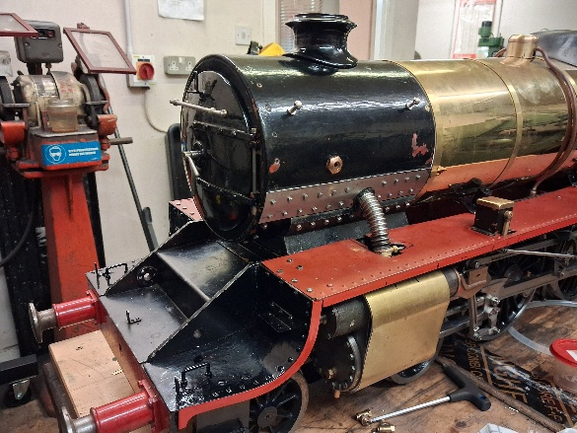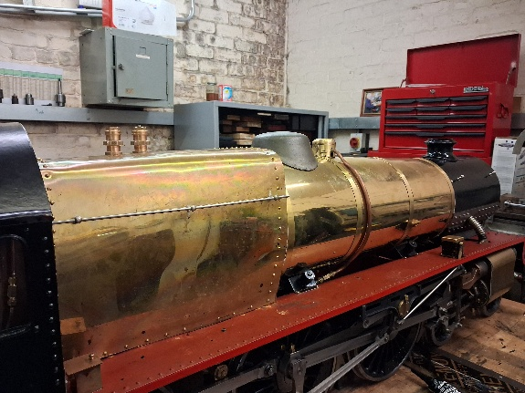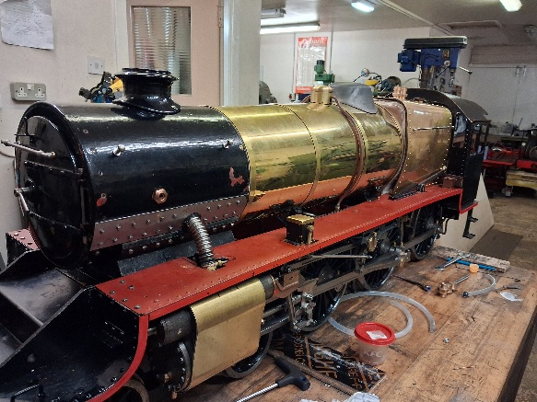
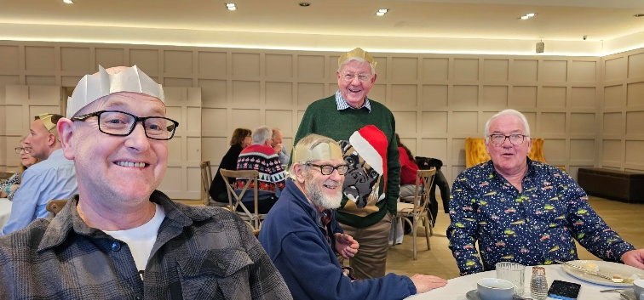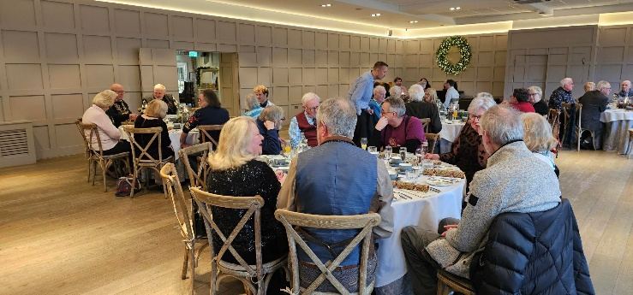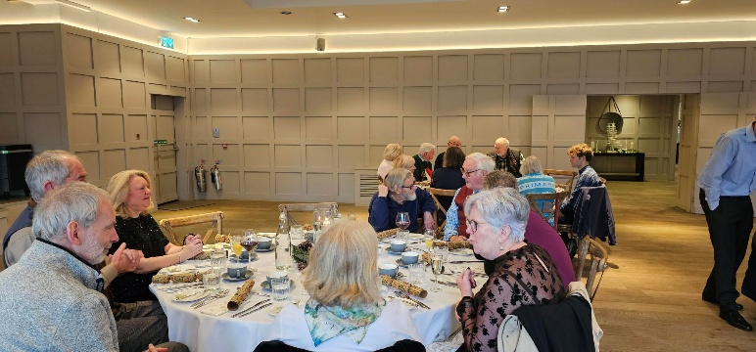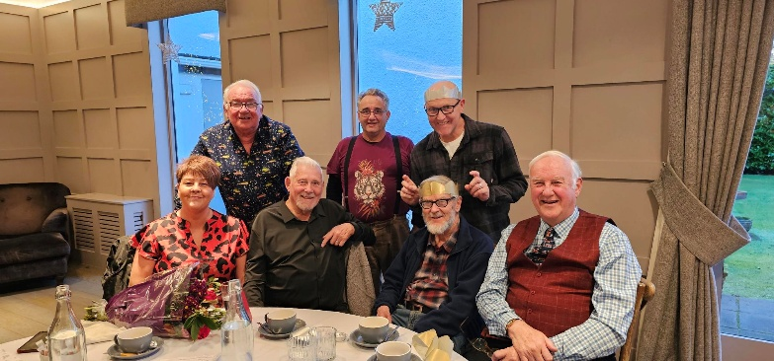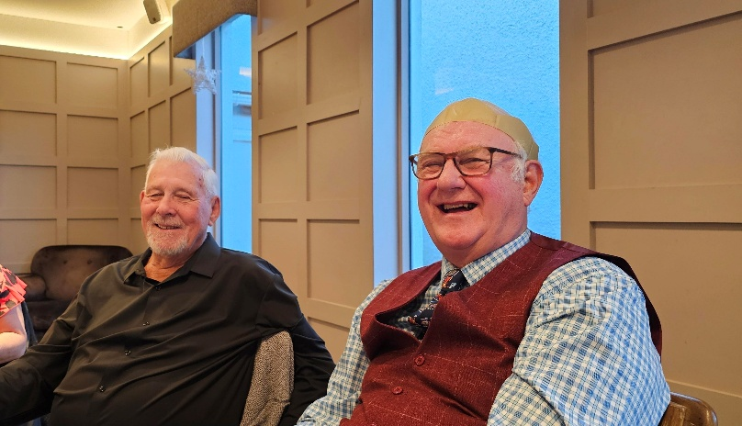

Christmas lunch pictures Thank you Heather for these images.

