STRATHAVEN MODEL SOCIETY Ltd
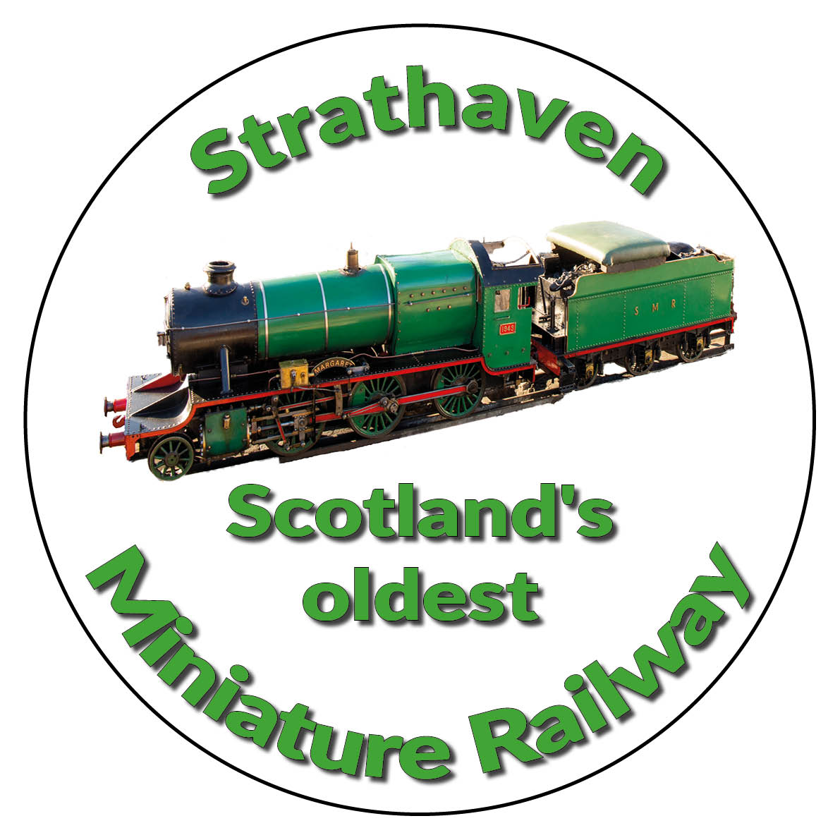
STRATHAVEN MINIATURE RAILWAY

A Simplified Classification of Locomotive Bogies
Symbols used:-
A - One powered axle
B - Two powered axles
C - Three powered axles
o - Indicates that axles are individually driven i.e. - there is a traction motor on each one of the axles
1 - One unpowered axle
These five symbols are used in combination:
Category* Diagram Classes* Number Detail
● ○ see below Bogies
Bo - Bo -●-●- -●-●- 17,20, 27, 67 2 B - Two powered axles
o - Driven by separate motors
Co – Co -●-●-●- -●-●-●- 37,47,55,66 2 C - Three powered axles
o - Driven by separate motors

A1A - A1A -●-○-●- -●-○-●- 31 2 A - One powered axle
1– One unpowered axle
A - One powered axle

1-Co - Co-1 ○-●-●-●- -●-●-●-○ 40,45 2 1 - One unpowered axle
C – Three powered axles
o – Driven by separate motors
● Indicates a powered axle
○ Indicates an unpowered axle
* This is not intended as an exhaustive list

STRATHAVEN MODEL SOCIETY Ltd
STRATHAVEN MINIATURE RAILWAY

Why have unpowered axles?
They help spread the weight of the locomotive on the track. This reduces the axle loading of the engine which increases its route availability (R.A). This means it could pass over a weak bridge which higher R.A. engines would not be able to do.
Note: all routes have a Route Availability category.
The downside is that unpowered axles reduce the tractive effort of a locomotive. This means that some of the weight of the locomotive is lost on an unpowered axle which reduces its ability to pull heavy trains and is therefore more likely to slip.
Steve Driver Version 1.1 31/05/22

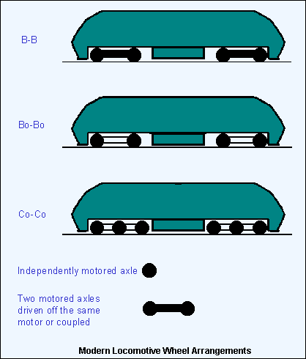

www.strathavenminiaturerailway.org facebook.com/strathavenminiaturerailway

