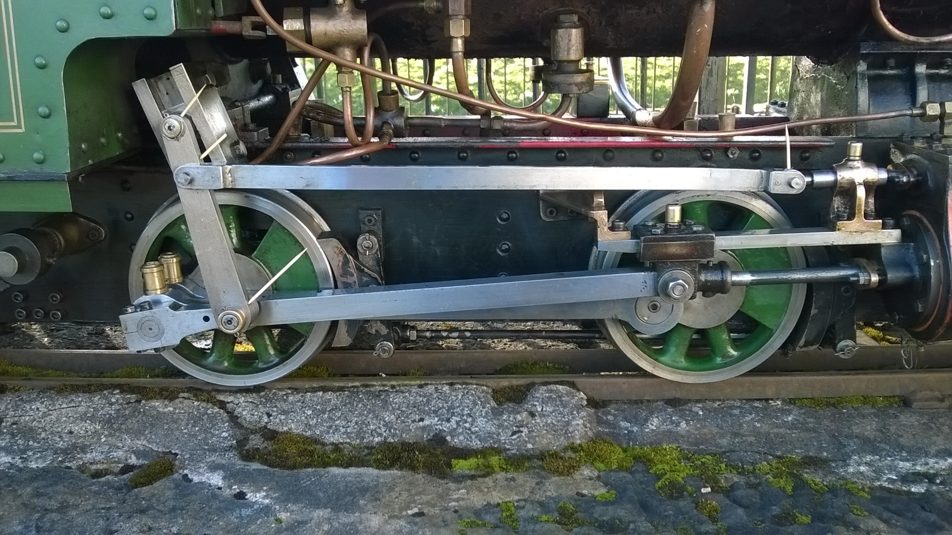
A.O. For Gudgeon pin inside slide unit
A.O.hidden by motion
A.O.
A.O.
A.O.
A.O.
A.O.
A.O .BETWEEN FRAMES
A.O.

A.O. AXLE or MACHINE OIL TO BE USED
OILING POINTS MARKED TO BE TOPPED UP DURING DAYS RUNNING
CO. CYLINDER OIL TO BE USED TOP UP DURING RUNNING DAY

A.O.Through spoke small amount on to axle, centre of wheel push ball in and oil
THESE A.O.ONCE AT START OF DAY
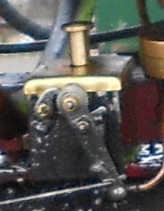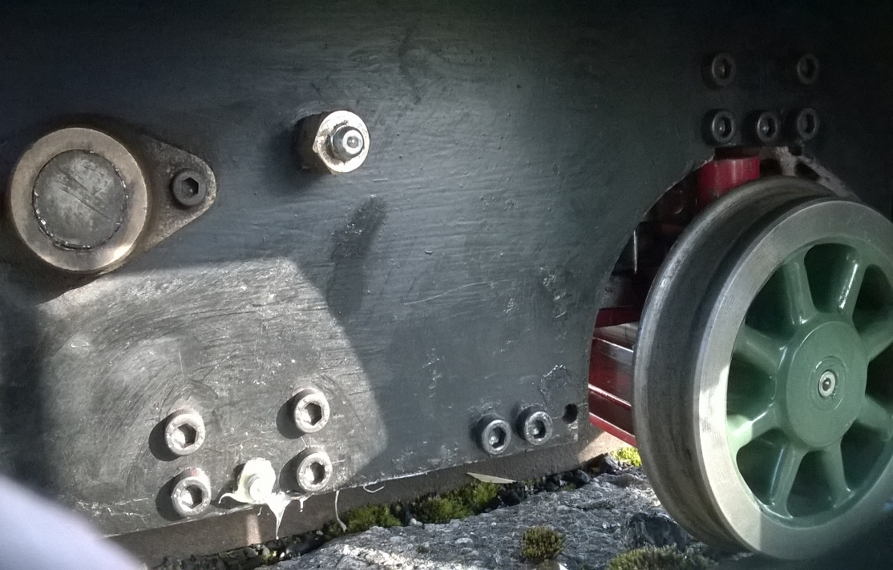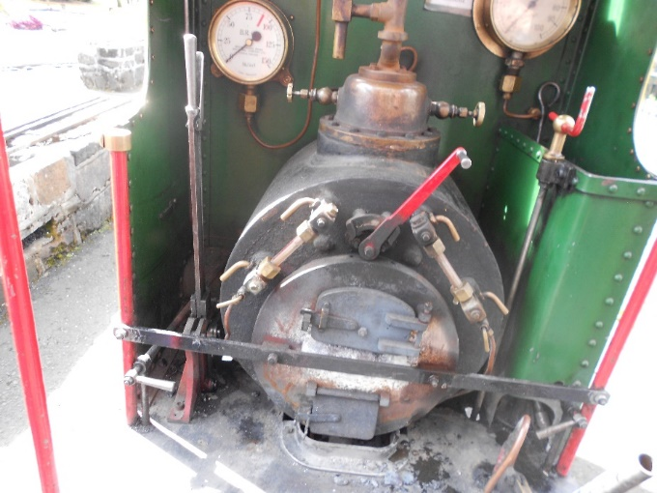
GREASE POINTS Monthly 1st of each month running days
CYLINDER OIL //
STEAM OIL TOP UP DURING RUNNING
A.O.
A.O.

G.P. GREASING POINTS TO BE DONE AT START OF EACH MONTH
CYLINDER OIL TOP UP AS REQUIRED DURING RUNNING DAY DO NOT ALLOW RESERVIOR TO RUN EMPTY

