MARGARET OILING POINTS
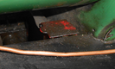
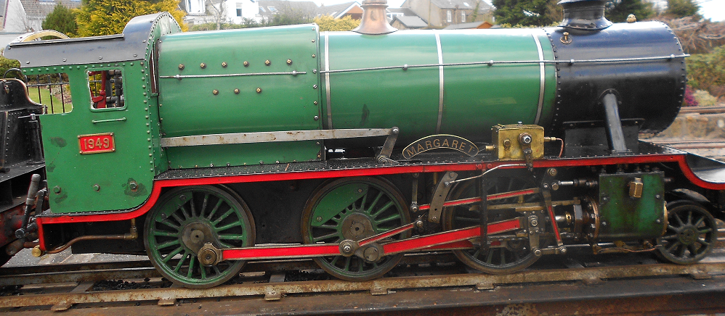
AO Four red boxes for axles
AO behind motion one oil cup
C.O.
AO axle and wheel block
AO Behind motion two oiling points
AO ON RUNNING BOARD
AO
AO
AO
AO
AO
AO
Figure 1
AO. AXLE or MACHINE OIL TO BE USED. OILING POINTS MARKED IN RED TO BE TOPPED UP DURING RUNNING DAY
CO. CYLINDER or STEAM OIL TO BE USED
MARGARET OILING POINTS

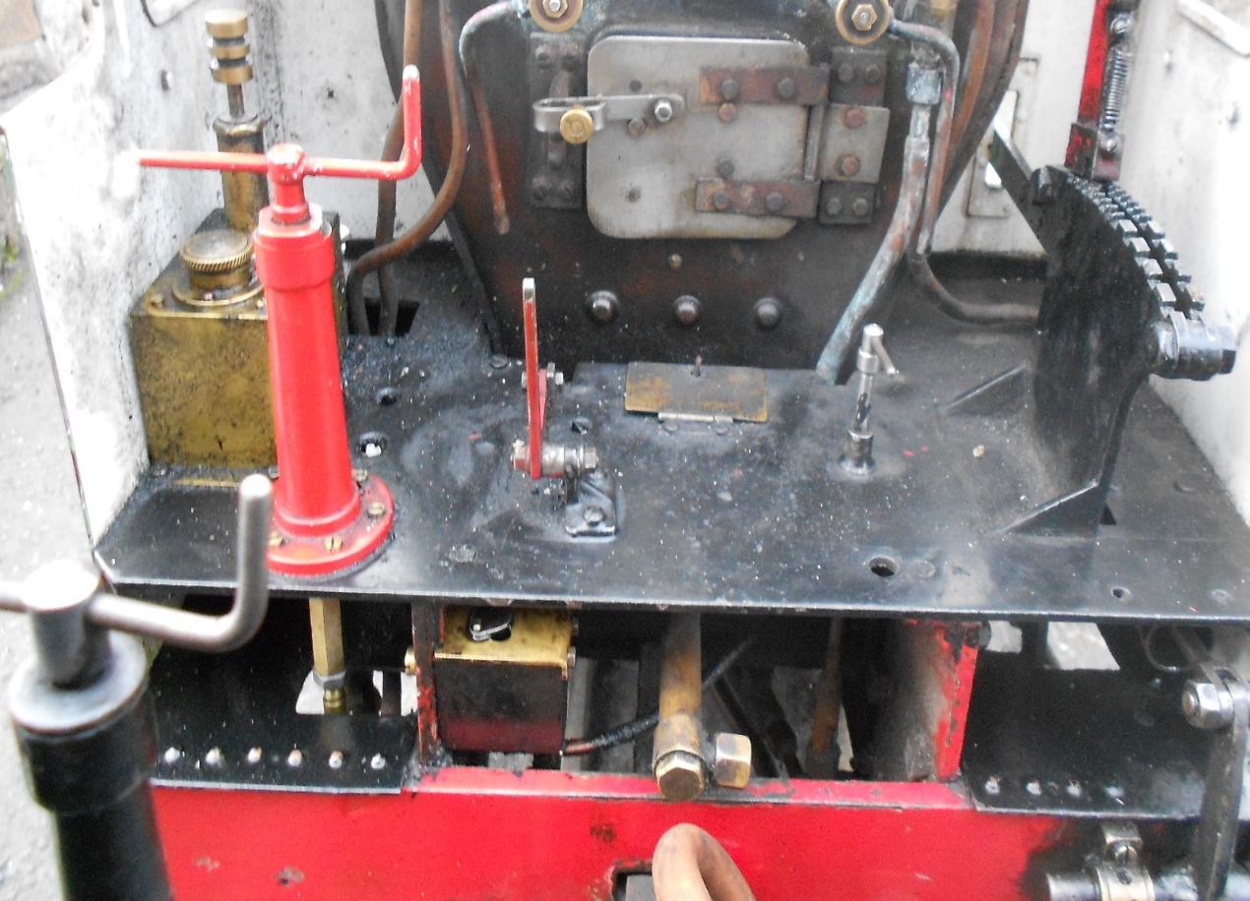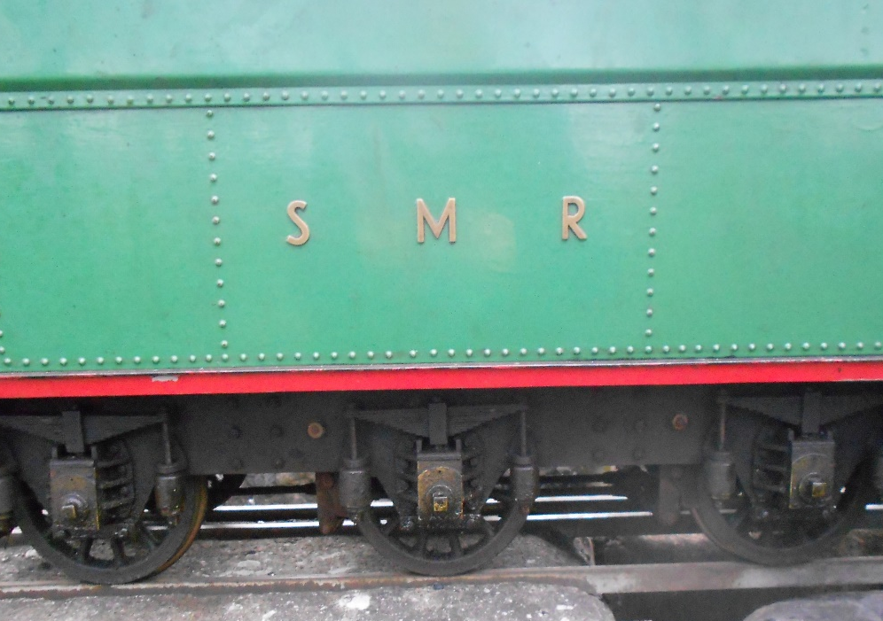
CO

AO
AO
Blow Down Valve
AO
AO
AO
AO. AXLE or MACHINE OIL TO BE USED.
CO. CYLINDER or STEAM OIL TO BE USED IF REQUIRED PUMP IN CAB IS FOR CYLINDERS WHEN OIL IS NOT BEING
SUPPLIED FROM RUNNING BOARD OILERS PUMP ONCE PER CIRCUIT

