STRATHAVEN LOCOMOTIVES

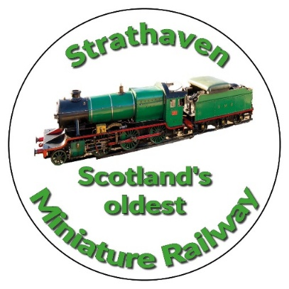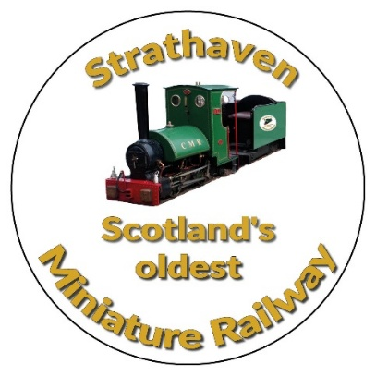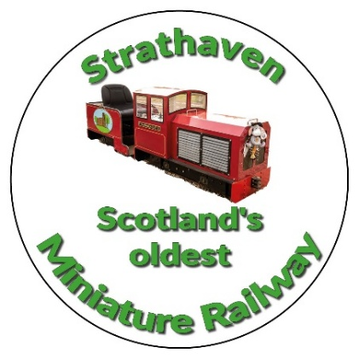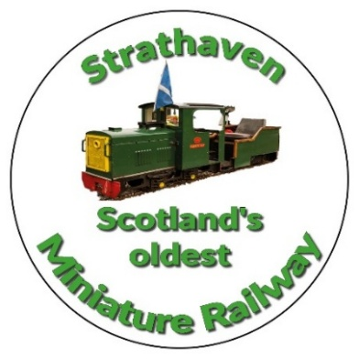
ABBERTON
0-4-0

Petrol Locomotive
Honda 5.5 hp engine
7¼̎ (184mm) GAUGE
BOUGHT IN 1993
Bought for day to day running. Can be used at the start and finish of a steam running day.
Ideal locomotive on poor weather days, simple switch on and off for full day running

STRATHAVEN CASTLE
0-4-0
Petrol Locomotive
Villiers 6,5 hp engine
7¼̎ (184mm) GAUGE
BOUGHT IN 2018.
Bought for day to day running. Can be used at the start and finish of a steam running day.
Ideal locomotive on poor weather days, simple switch on and off for full day running
EVA
Hunslet Saddle tank design
0-4-2
Steam Locomotive
7¼̎ (184mm) GAUGE
Built by a club member
Built 1992 - 1994
Donated to the Society in 2007 by the builder.

New boiler fitted in 2021
Used on most steaming days throughout the year. When steam drivers are available
MARGARET
Based on a G.W.R.
Great Western Railways
Mogul design
2-6-0
Steam Locomotive
7¼̎ (184mm) GAUGE
BUILT 1947-1949.
First operating day in the park
14TH OF MAY 1949.
76 Years old and still in working condition
Used only on special days and when steam drivers are available
Has been rebuilt twice in her lifetime

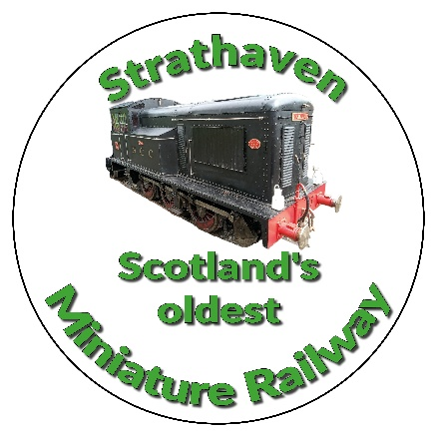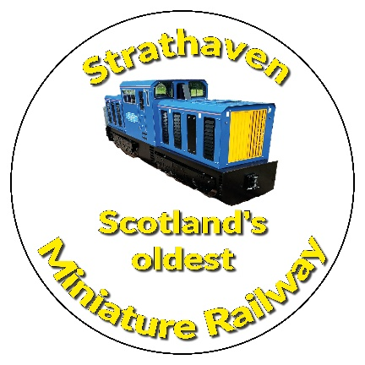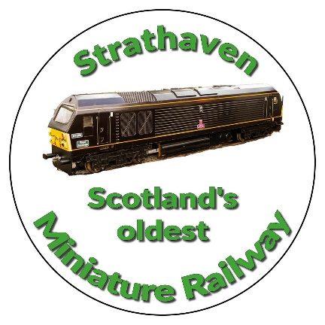
Neptune
Similar to Clayton Class 17 locomomotive
BO-BO
7¼̎ (184mm) GAUGE
BATTERY Powered 24V. Locomotive
Supplied by Abbot Model Engineering (2023)
Neptune has all wheels driven by electric motors similar to real life BO-BO locomotives Each bogie is articulated making it very versatile on tighter curves. She is also very powerful easily pulling our new carriages in the park when made up into a train.
She has twin horns and the very similar hand controller as Titan
117 of this class built in real life 1962-1965.

Titan
Class X No17
0-6-0
7¼̎ (184mm) GAUGE
BATTERY Powered 24V. Locomotive
Our loco was built from the Shipyards drawings by a highly skilled engineer and member, who donated the loco to Strathaven just before his death in 2020 Fitted with a sound card and horn.
There was only one member of Class X, No.17. It was built by Harland and Wolff in Belfast and delivered to the NCC (Northern Counties Committee) in 1936 under a lease arrangement; it was not actually taken into stock until 1941 when the NCC purchased it. No.17 has a 0-6-0 wheel arrangement and was powered by an eight-cylinder diesel engine developing 330 bhp (250 kW) at 1200 rpm.
Scrapped 1970s
https://en.wikipedia.org/wiki/NCC_Class_X

Royal Sovereign
CLASS 67
BO-BO
5” (127mm) GAUGE
BATTERY Powered 24V. Locomotive
BOUGHT 2021. (£2000 second hand)
For our junior members.
Ideal locomotive for children. Easy to learn how to drive around our tracks. Remote switch can be used to stop the locomotive anywhere on our tracks by the supervising member. Each bogie is articulated making it very versatile on tighter curves. She is also very powerful
Can be used by all club members.
30 of this class were built in real life EWS (English, Welsh and Scottish Railways was the most common livery
1999-2000

