STRATHAVEN MODEL SOCIETY Ltd
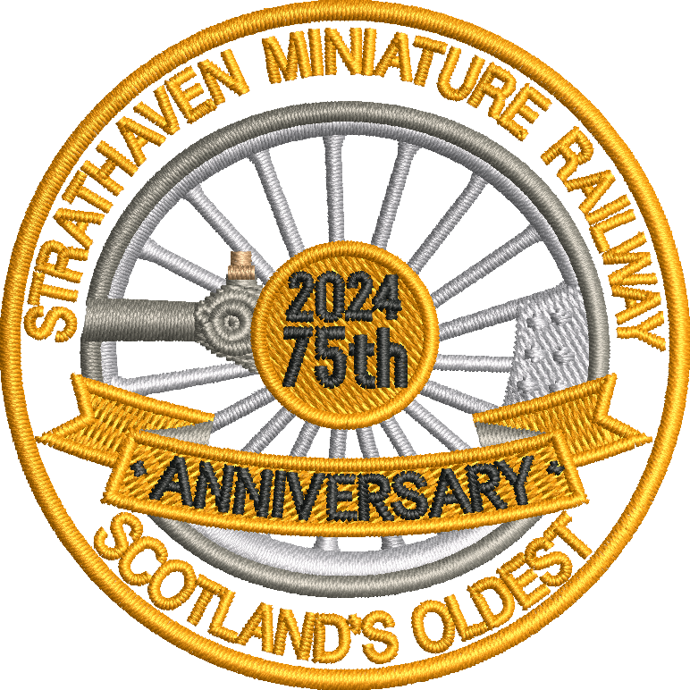
STRATHAVEN MINIATURE RAILWAY

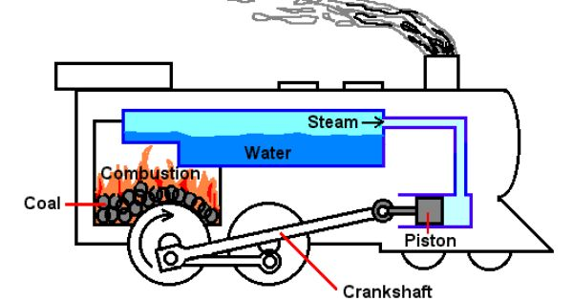
Steam locomotives need the following,
COAL as fuel to burn in the firebox,
WATER in the boiler to be heated by the fire,
Water is turned into STEAM. This goes into the pistons and makes the crankshaft turn the wheel,
OIL is also needed to keep all the moving parts lubricated so that they can move smoothly.

COAL is a flammable black hard rock used as a solid fossil fuel. The major source of fuel throughout the world is coal. Coal is a black or brown rock that, when burned, releases energy in the form of heat. One of coal's main uses is the production of electricity. The coal used today began forming about 300 million years ago. At that time swamps with giant ferns and other plants were common on Earth. When these plants died, they sank in the water. They did not completely decay, or break down. Instead they formed a substance called peat. Over time layers of rock and other materials built up over the peat. Heat and pressure hardened the peat into coal.
Lignite - is the lowest rank of coal - which means that it has the lowest heating value and lowest carbon content. Available worldwide (Poland and China large producers. (House Coal )

Bituminous - is intermediate in rank and sometimes called soft coal. It appears smooth when you first see it, but look closer and you'll find it has many layers. It is the most abundant kind of coal. It has a high heating value, but it also has a high sulphur content. You can buy several grades or qualities of this type of coal. Ours has higher content of carbon content with only 2% ash. Source country (Columbia) (Steam Coal Lower Grade)

Anthracite - is the highest rank of coal which means that it has the highest heating value and highest carbon content. It is very hard, deep black, and looks almost metallic because it is brilliantly glossy. Anthracite burns longer, with more heat and with less ash and soot than other types of coal. Source country Wales.
(Steam coal highest grade)

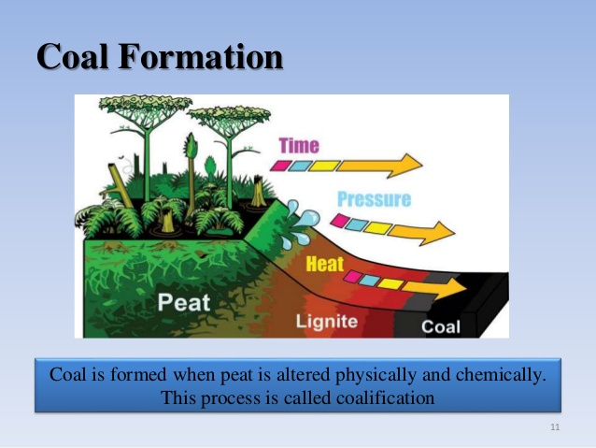

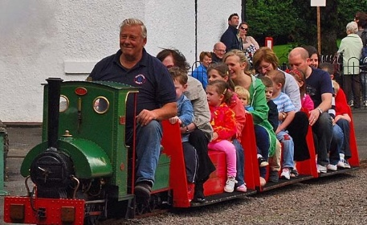

www.strathavenminiaturerailway.org facebook.com/strathavenminiaturerailway

