STRATHAVEN MODEL SOCIETY Ltd
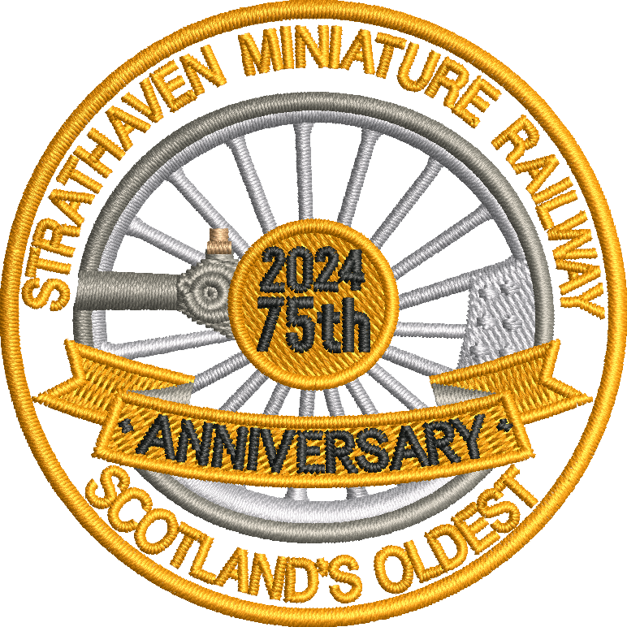
STRATHAVEN MINIATURE RAILWAY
Steam at top of the boiler
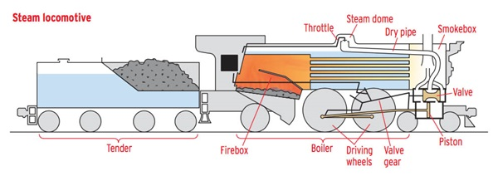
Water in the Boiler
5
4
3
6
2
1
FIRE
COAL=ANTHRACITE

WATER
Steam locomotives need the following,
COAL as fuel to burn in the firebox,
WATER in the boiler to be heated by the fire,
Water is turned into STEAM. This goes into the piston and makes the crankshaft turn the driving wheels,
OIL is also needed to keep all the moving parts lubricated so that they can move smoothly.

1/ Firebox with coal burning creating heat (Combustion)
2/ Boiler with water heated by the fire turns water into Steam
3/ Steam enters pistons to create motion
4/ Piston slides back and forwards within cylinder.
5/Piston moves valve gear transfers motion to wheels
6/ Driving wheels create movement in this case forward

COAL is a flammable black hard rock used as a solid fossil fuel. The major source of fuel throughout the world is coal. Coal is a black or brown rock that, when burned, releases energy in the form of heat. One of coal's main uses is the production of electricity. The coal used today began forming about 300 million years ago. At that time swamps with giant ferns and other plants were common on Earth. When these plants died, they sank in the water. They did not completely decay, or break down. Instead they formed a substance called peat. Over time layers of rock and other materials built up over the peat. Heat and pressure hardened the peat into coal.

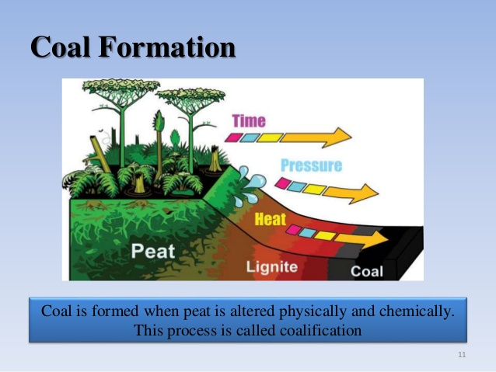
Lignite - is the lowest rank of coal - which means that it has the lowest heating value and lowest carbon content. Available worldwide (Poland and China large producers. (House Coal)

Bituminous - is intermediate in rank and sometimes called soft coal. It appears smooth when you first see it, but look closer and you'll find it has many layers. It is the most abundant kind of coal. It has a high heating value, but it also has a high sulphur and ash content. You can buy several grades or qualities of this type of coal. Ours is the highest quality with a high content of carbon and produces less than 2% ash. Source country (Columbia) (Steam Coal Medium Grade)

Anthracite - is the highest rank of coal which means that it has the highest heating value and highest carbon content. It is very hard, deep black, and looks almost metallic because it is brilliantly glossy. Anthracite burns longer, with more heat and with less ash and soot than other types of coal. Source country Wales.
(Steam coal highest grade)

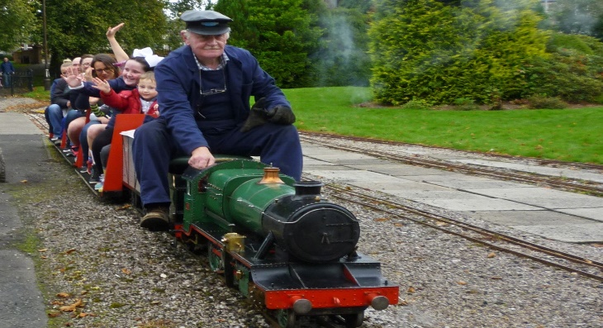

www.strathavenminiaturerailway.org facebook.com/strathavenminiaturerailway

