STEAM ENGINE WHEEL CONFIGURATION SIMPLIFIED VERSION
Frederick Methvan Whyte (1865 – 1941- 76 years old) was a mechanical engineer of Dutch background who worked for the New York Central in the United States.
He is most widely known as the person who developed THE WHYTE NOTATION to describe the different wheel arrangements of steam locomotives in 1900.
Steam Locomotives can have three types of wheels:
Leading wheels
DRIVING WHEELS
Trailing wheels
All locomotives have DRIVING WHEELS but not all have leading or trailing wheels.
- Leading Wheels are not powered and sit in front of the Driving Wheels to help support the front of the locomotive round curves and points. The number of Leading Wheels is signified by the first number in WHYTE’S NOTATION.

- Driving Wheels are those that actually move the locomotive pistons and rods. With the wheels normally sitting centrally underneath the boiler and are larger than the other wheels on the locomotive. The number of Driving Wheels is signified by the middle set(s) of numbers in WHYTE’S NOTATION

- Trailing Wheels sit behind the Driving Wheels and often simply support the cab and firebox in large locomotives. The number of Trailing Wheels is denoted by the final number in WHYTE’S NOTATION

- Whyte Notation is written to represent the number of wheels, with the three types of wheel separated by hyphens
Example 2-4-2 (2 leading wheels 4 drive wheels and 2 trailing wheels)
.
All locomotives have Driving Wheels but not all have leading or trailing wheels.

www.strathavenminiaturerailway.org Facebook.com/strathavenminiaturerailway
STEAM ENGINE WHEEL CONFIGURATION SIMPLIFIED VERSION
Locomotives without Leading or Trailing Wheels still have to be accounted for, and so in the example over the page where the locomotive now just has 4 driving wheels the designation would be known as an 0-4-0 locomotive.

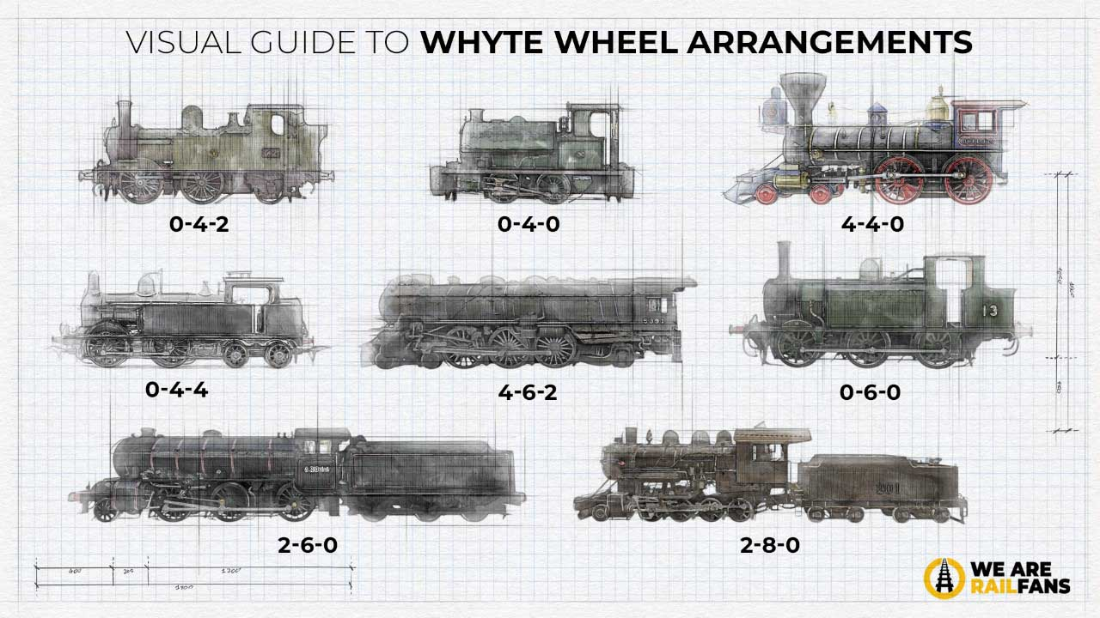
www.strathavenminiaturerailway.org Facebook.com/strathavenminiaturerailway

STEAM ENGINE/ DIESEL WHEEL CONFIGURATION SIMPLIFIED VERSION

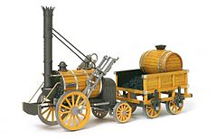
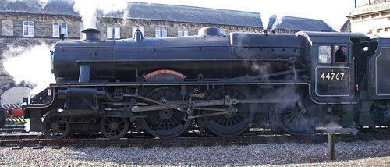
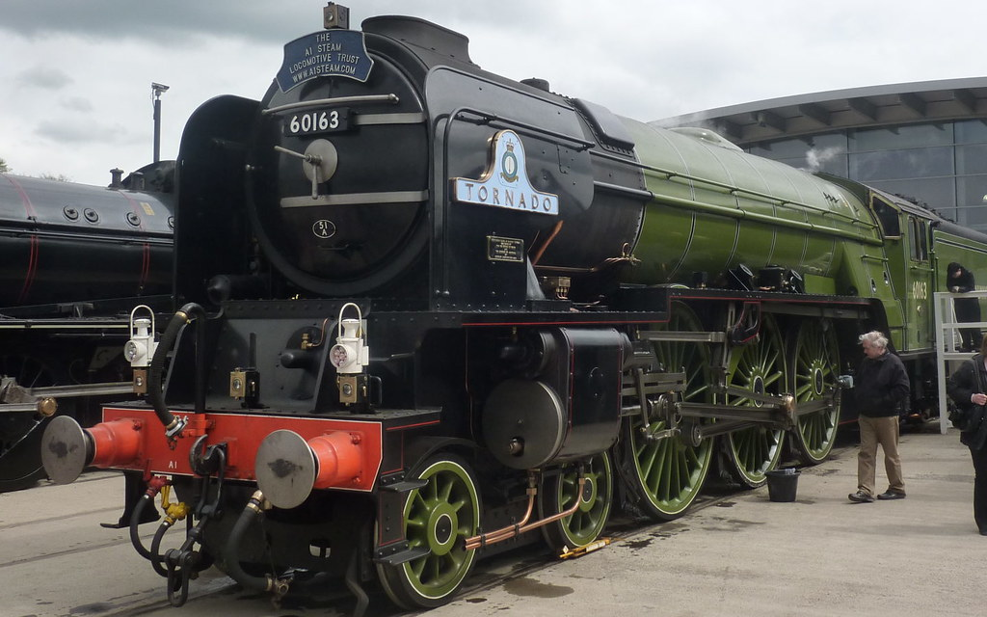
4-6-0 (169) | Ten Wheeler  Black 5  see picture
4-6-2 (244) | Pacific  Tornado  see picture
4-6-4 (2) | ---
AIA-AIA (21) | ---
B-B (11) | ---
BO (18) | ---
BO-BO (287) | Class 67  Royal Sovereign  Neptune (Class 17)
C-C (7) | ---
CO-BO (1) | ---
CO-CO (188) | ---

NOTATION | NAME | IMAGE
0-2-2 | Rocket  See picture
0-4-0 | Strathaven Castle  And Abberton
0-4-2 | GWR 14XX /Oliver  / Eva
0-4-4 | ---
0-6-0 | Holmside
0-6-2 | ---
2-10-0 | Decapod
2-6-0 | Mogul (Margaret)
2-6-2 | Prairie
2-6-4 | Adriatic
2-8-0 | Consolidation
4-2-2 (11) | Single Wheeler
4-4-0 (62) | ---

www.strathavenminiaturerailway.org Facebook.com/strathavenminiaturerailway
STEAM ENGINE WHEEL CONFIGURATION SIMPLIFIED VERSION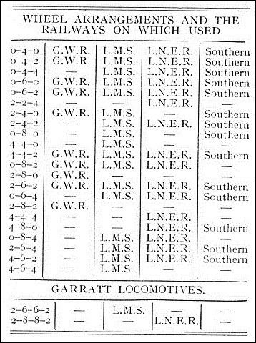
THE BIG FOUR 1923
The Great Western Railway (GWR) was a British railway company that linked London with the southwest and west of England, the West Midlands and most of Wales. It was founded in 1833, received its enabling Act of Parliament on 31 August 1835 and ran its first trains in 1838. It was engineered by Isambard Kingdom Brunel, who chose a broad gauge of 7 ft (2,134 mm)—later slightly widened to 7 ft ¹⁄₄ in (2,140 mm)—but, from 1854, a series of (amalgamations) saw it also operate 4 ft 8+¹⁄₂ in (1,435 mm) standard-gauge trains; the last broad-gauge services were operated in 1892.
The GWR was the only company to keep its identity through the Railways Act 1921, which (amalgamated) it with the remaining independent railways within its territory, and it was finally merged at the end of 1947 when it was nationalised and became the Western Region of British Railways.
The London, Midland and Scottish Railway (LMS) was a British railway company. It was formed on 1 January 1923 under the Railways Act of 1921,^{[1]} which required the grouping of over 120 separate railways into four. The companies merged into the LMS included the London and North Western Railway, Midland Railway, the Lancashire and Yorkshire Railway (which had previously merged with the London and North Western Railway on 1 January 1922), several Scottish railway companies (including the Caledonian Railway), and numerous other, smaller ventures.
The London and North Eastern Railway (LNER) produced several classes of locomotive, mostly to the designs of Nigel Gresley, characterised by a three-cylinder layout with a parallel boiler and round-topped firebox. It produced the most famous locomotive of its day, 4468 'Mallard', the holder of the world steam locomotive speed record. It also built the world-famous 4472 'Flying Scotsman'. However, its locomotive inheritance was much greater than just the 'A4 Class', it also produced highly successful mixed-traffic and freight designs.
The Southern Railway (SR), sometimes shortened to 'Southern', was a British railway company established in the 1923 Grouping. It linked London with the Channel ports, South West England, South coast resorts and Kent. The railway was formed by the (amalgamation) of several smaller railway companies, the largest of which were the London & South Western Railway (LSWR), the London, Brighton and South Coast Railway (LB&SCR) and the South Eastern and Chatham Railway (SE&CR).^{[1]} The construction of what was to become the Southern Railway began in 1838 with the opening of the London and Southampton Railway, which was renamed the London & South Western Railway.
(AMALGAMATED) = Join together, merge, combine or unite to form one organization or structure.

www.strathavenminiaturerailway.org Facebook.com/strathavenminiaturerailway

