STRATHAVEN TRACK & POINTS
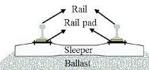
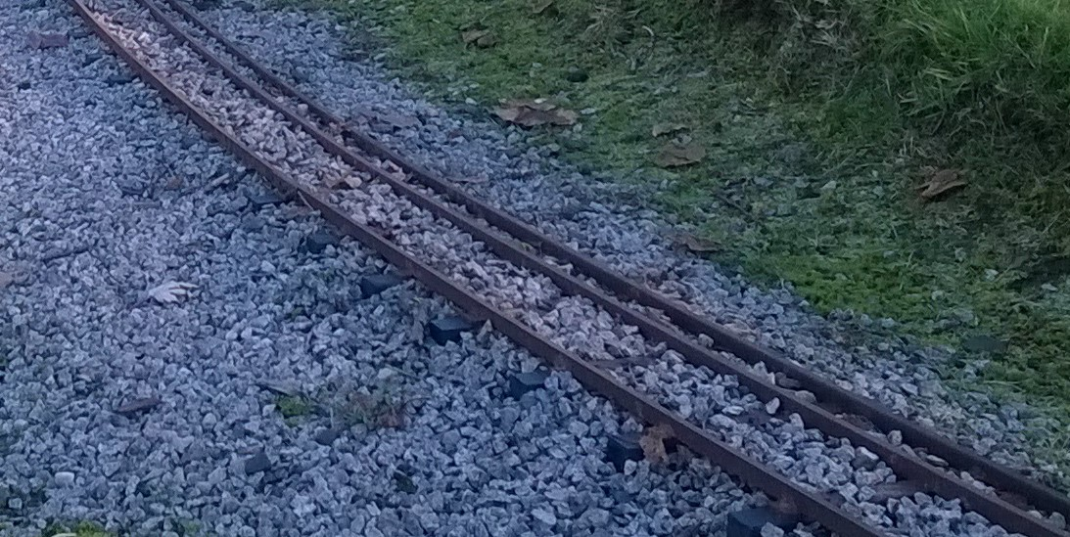
GAUGE OF TRACK IN PICTURE.
7¼̎ (184mm) GAUGE
OUTSIDE TWO RAILS

5” (127mm) GAUGE
INSIDE RAIL AND
OUTSIDE RAIL

RAIL PADAIL
RAILAIL
BALLAST
SLEEPER
www.strathavenminiaturerailway.org Facebook.com/strathavenminiaturerailway

STRATHAVEN TRACK & POINTS
Tie bar
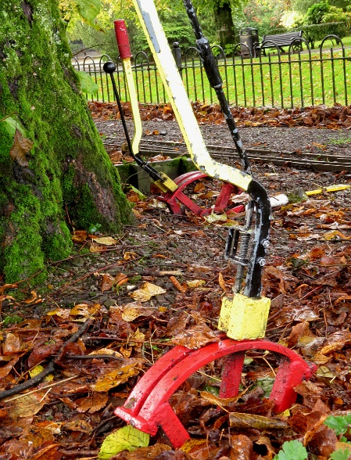
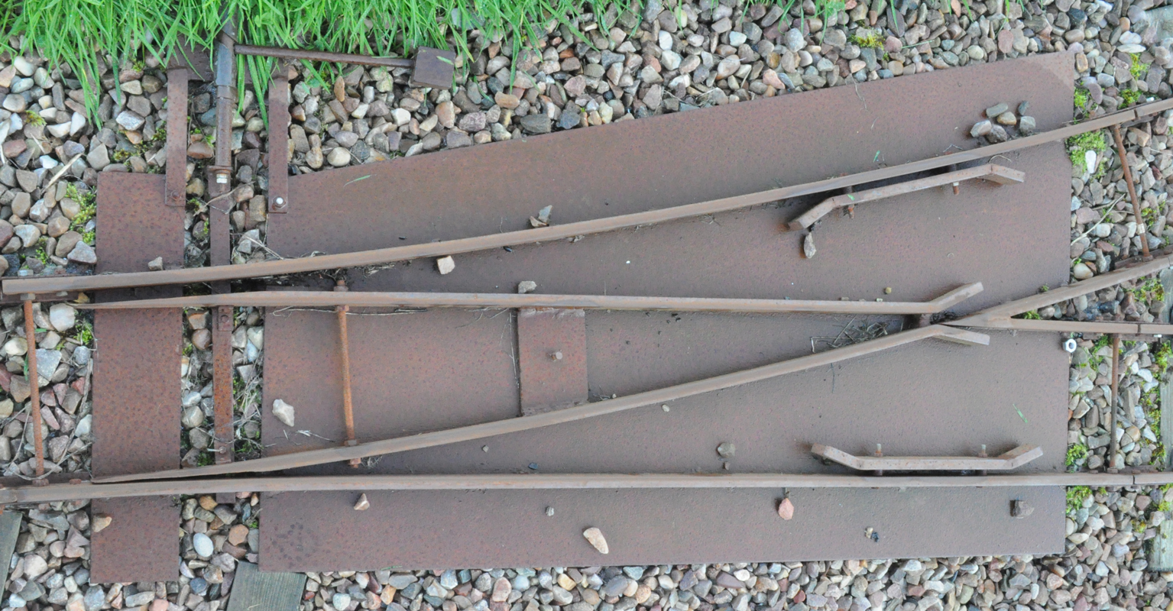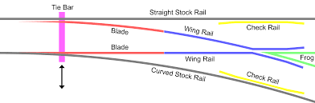
CHECK RAIL KEEPS WHEEL ON TRACK AT POINTS AND THE DIAMOND
POINT LEVERS AT TRACK SIDE POINT LEVER. VERTICAL FOR STRAIGHT THROUGH TRAFFIC.
PULLED OVER AT AN ANGLE INDICATES TURN / CHANGE OF DIRECTION
CHECK BETWEEN BLADES FOR STONES OR OTHER PIECES OF RUBBISH THAT MAY BLOCK MOVEMENT OF POINT BLADES. POTENTIAL TO CAUSE DE-RAILMENT IF NOT CLEAR
Frog
Blade
Blade
Curved stock rail
Check rail
Wing rail
Wing rail
Check rail
Straight stock rail
BLADES MOVES A SHORT DISTANCE ON EACH SET OF POINTS. MAKES TRAIN CHANGE DIRECTION
www.strathavenminiaturerailway.org Facebook.com/strathavenminiaturerailway

