STRATHAVEN AXLE WITH WHEELS FOR CARRIAGES
PARTS OF A PAIR OF WHEELS
FLAT:- the running area of a wheel in contact with the rail. In some cases called a tyre which includes the flange.
RIM or Flange:- is a part of the wheel which keeps it on the rails
Example of how it would look like looking straight on at it
WEB:- Area of the wheel from the hub to the outer rim or flange. So called that on the very first carriages they had spokes or holes drilled into them
AXLE:-Joins the two wheels through the centre of the wheel (Hub)
HUB:- Hole in the centre of the wheel which the axle goes through , Can be welded or press fitted to the axle

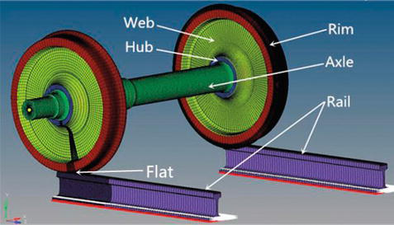

www.strathavenminiaturerailway.org Facebook.com/strathavenminiaturerailway

STRATHAVEN AXLE WITH WHEELS FOR CARRIAGES

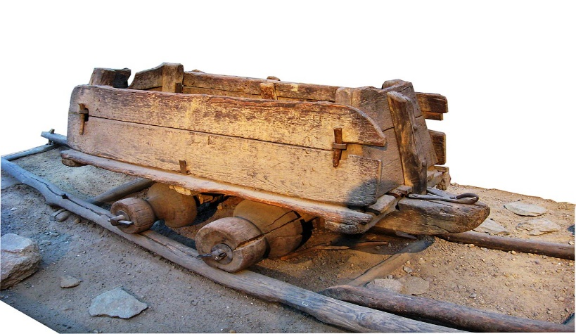
First wagons all made of wood, Rails were logs. Pushed by hand or pulled or using an animal (Horse, Ox, Dogs etc.
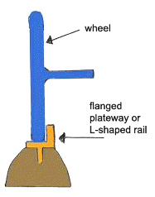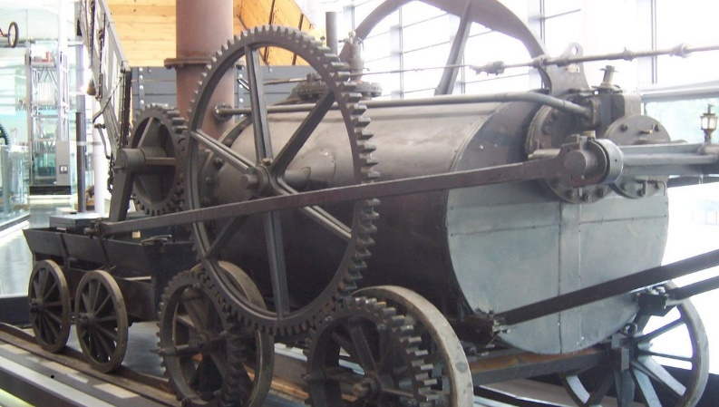
Before 1789 most metal tracks /rails were L shaped similar to picture on the left. The wheel rim was flat similar to the picture on the left and the right.
William Jessop invented the flanged wheel in 1798.
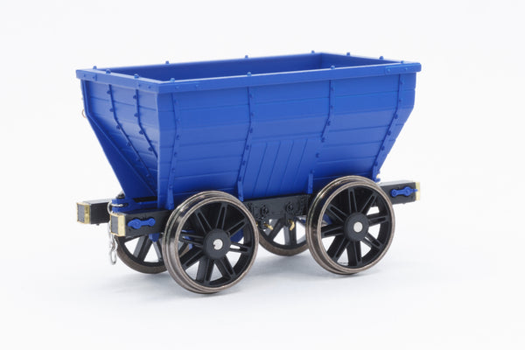
www.strathavenminiaturerailway.org Facebook.com/strathavenminiaturerailway

First wagons had spoked web wheels. Passengers just stood in side tub
WHEEL CIRCUMFERENCE
HOW FAR DOES THE WHEEL TRAVEL FROM STARTING POINT TO FINISHING POINT

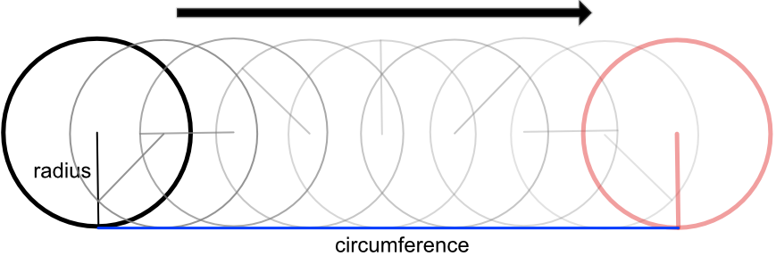
FINISH
START
DEPENDING ON THE SIZE OF THE WHEEL WE CAN WORK OUT HOW FAR IT CAN TRAVEL IN ONE ROTATION.
Blue 5”carriage wheel 1 CIRCLE OR TURN = 25cm
4 turns or circles of carriage wheel = 1metre or 100cm
Strathaven track measures outside track = 230 metres or 23,000cm
Strathaven Complete track measures 692 metres or 69,200cm

WHEEL CIRCUMFERENCE
HOW FAR DOES THE WHEEL TRAVEL FROM STARTING POINT TO FINISHING POINT

We measured each of the junior’s foot size and they varied from 22cm to 28cm in length

Foot length | 1metre | Outside loop 230 metres | Full Track 692 metres
22cm | 4 ½ steps to cover this distance | 1045 steps to cover this distance | 3145 steps to cover this distance
23cm | 4.3 steps to cover this distance | 1000 steps to cover this distance | 3008 steps to cover this distance
24cm | 4.1 steps to cover this distance | 958 steps to cover this distance | 2883 steps to cover this distance
25cm | 4 steps to cover this distance | 920 steps to cover this distance | 2768 steps to cover this distance
26cm | 3.8 steps to cover this distance | 884 steps to cover this distance | 2661 steps to cover this distance
27cm | 3.7 steps to cover this distance | 852 steps to cover this distance | 2563 steps to cover this distance
28cm | 3.5 steps to cover this distance | 821 steps to cover this distance | 2471 steps to cover this distance

We measured some of the engines and carriages wheels size and they varied from 25cm to 63cm in circumference

Wheel travel after one rotation | 1metre | Outside loop 23,000cm | Full Track 69,200 cm
NEW Blue 5 inch carriages 25cm | 4 rotations | 920 rotations | 2768 rotations
New Blue 7¼´´ carriages 29cm | 3.44 rotations | 793 rotations | 2383 rotations
Old Red large carriages 47 cm | 2 rotations | 489 rotations | 1472 rotations
Class 67 Royal Sovereign 25cm | 4 rotations | 920 rotations | 2768 rotations
Neptune drive wheels 41.9cm | 2.4 rotations | 549 rotations | 1652 rotations
Titan Drive wheels 44.5 cm | 2.3 rotations | 517 rotations | 1555 rotations
Margaret pony/ guide wheels 34cm | 3 rotations | 657 rotations | 1977 rotations
Margaret main drive wheels 63cm | 1.6 rotations | 377 rotations | 1098 rotations
www.strathavenminiaturerailway.org Facebook.com/strathavenminiaturerailway

